April 2020
New challenges create new initiatives at Kaeser

As social distancing becomes the new norm for the foreseeable and New Zealand moves to COVID-19 Alert Level 3, Kaeser Compressors has launched two new initiatives - Contactless Service and the Compressed Air Assessment 4.0. Both initiatives have been developed to ensure that compressed air users can continue to operate reliable and efficient compressed air systems.

Contactless Service
Now more than ever businesses need to be able to rely on their equipment, and certainly when it comes to the compressed air system, continuing to follow the OEM’s (original equipment manufacturers) recommended maintenance schedule will have a large impact on its ongoing reliability.

Compressed air is often considered the fourth utility to industry and so maintaining a compressed air system will be essential to many businesses. This means allowing compressed air Service Technicians onsite to perform maintenance work.

Kaeser Air Service Technicians remained available to essential businesses and services throughout COVID-19 Alert Level 4 that required on-site compressed air service support, and so some weeks ago Kaeser implemented a number of preventive measures for their Service Technicians in the field.
This includes: using hand sanitiser before entering a customer’s site, wearing protective gloves to service equipment, where required wearing a face mask, and disinfecting all equipment before and after servicing.

For added peace of mind Kaeser has now also introduced Contactless Service which further limits the physical contact between the end user and the Service Technician.

When a customer opts for Contactless Service with Kaeser, the Service Technician phones the customer when they get to site to announce their arrival and discuss the service requirements. After taking a number of preventive measures before entering the site, the Service Technician then proceeds to service the compressed air equipment. After completing the service work and taking photos of the equipment serviced including used parts, the Service Technician then phones the customer before leaving site to explain all work completed. All paperwork is then sent to the customer by email.

Compressed Air Assessment 4.0
There is no doubt that in the current climate all businesses are looking for ways to minimise their outgoings. Electricity remains a significant cost to industry, and electrical power on average accounts for up to 90 percent of the total costs for compressed air production. Finding ways to optimise the energy efficiency of a compressed air system could therefore go a long way in reducing a businesses electricity bills.

With that in mind and taking into account the fact that many businesses are now limiting access to their sites, Kaeser has developed the Compressed Air Assessment 4.0.

With the Compressed Air Assessment 4.0, Kaeser has taken its air assessment online. Rather than a Kaeser representative conducting a walkthrough and assessment of a compressed air system in person this is now completed remotely. All the end user needs to do is supply a video of their compressed air system. Kaeser then follows up with a brief phone call to gather some additional information.
The compressed air experts at Kaeser then analyse all information supplied and generate a report of findings and recommendations. Finally, Kaeser shares these findings and recommendations with the end user via a conference call as well as guidance on suggested next steps.

Peter Eckberg, Managing Director of Kaeser Compressors NZ concluded: ‘We have taken a number of steps in the past few weeks to mitigate the impact of the current situation. We have also developed initiatives to ensure that we can continue to support compressed air end users, not only with the ongoing maintenance of their existing equipment, but also in optimising its efficiency and reliability.
We remain fully committed to supporting compressed air users through these unprecedented times to the best of our ability and within the scope of Government requirements.’

For more information visit nz.kaeser.com or phone 0800 447 820.
-END-
Editors Notes
From 0.18 to 515 kW, Kaeser Compressors manufactures a wide range of compressors and associated auxiliary equipment that meet the varying requirements of a diverse range of industries and applications.

One of the world’s largest manufacturers of rotary screw compressors, Kaeser Compressors is represented globally in over 100 countries through a dedicated network of branches, subsidiary companies and authorised partners.

Kaeser Compressors NZ Limited provides comprehensive air compressor and blower sales and service throughout New Zealand from its offices in Auckland, alongside a dedicated and nationwide network of authorised partners.

For editorial and advertising enquiries contact: Beth Wood, Marketing Manager
Press office: +61 3 9791 5999 Fax: +61 3 9791 5733
E-mail: beth.wood@kaeser.com

KAESER COMPRESSORS NZ Limited
18B Tarndale Grove, Albany, Auckland 0632, New Zealand
Phone: +64 9 941 0499 Email: info.newzealand@kaeser.com
nz.kaeser.com

File: P-Kaeser-new-initiatives-nz
Approved for publication, copy acknowledgement appreciated
Images:

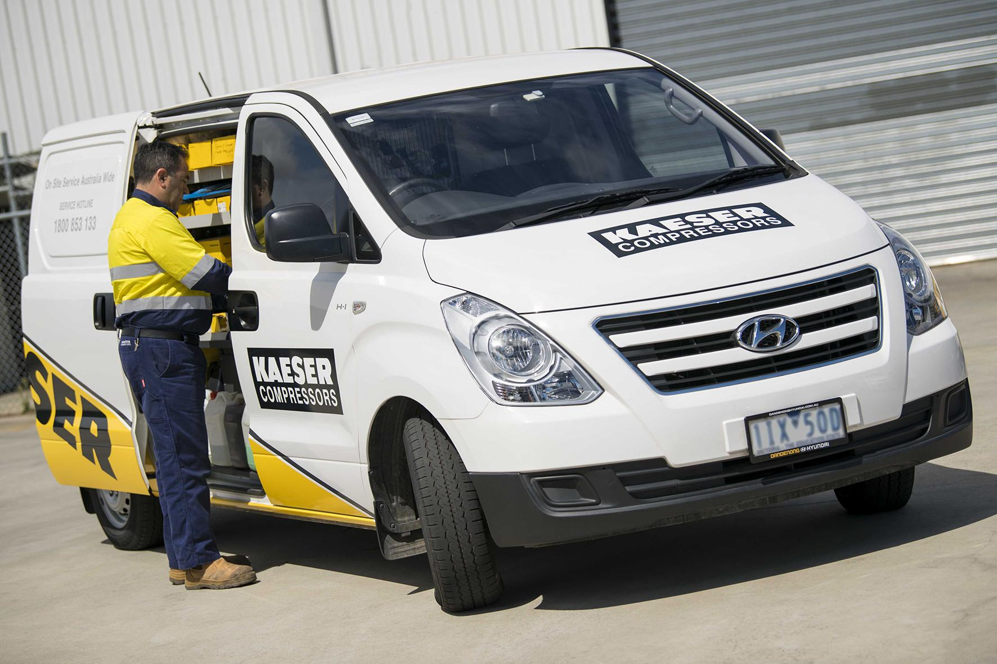
Caption: Kaeser has introduced Contactless Service which further limits the physical contact between the end user and the Service Technician.

Caption: With the Compressed Air Assessment 4.0, Kaeser has taken its air assessment online.

Kaeser photo(s) – free for publication, credits appreciated.

