May 2019

Peak performance powerhouses:
Kaeser extends its range of high efficiency screw blowers

The recently launched HBS series of screw blowers from Kaeser Compressors, set a new benchmark in compressor technology for the 132 to 250 kW power range, with flow rates from 60 to 160 m³/min and differential pressures up to 1100 mbar. These powerhouses not only feature exceptional control characteristics, quiet operation, optimised footprint and low maintenance requirement – they also deliver consistently high efficiency across the entire control range.

The efficiency of the HBS screw blower remains consistent across the entire control range, not just at certain specific levels, which will make this machine an especially attractive alternative to turbo compressors. This new screw blower for the low-pressure range draws on Kaeser’s many decades of expertise in the development of highly efficient rotary screw compressors and automation technology, through to smart machines, in order to meet the needs of Industrie 4.0 environments. The new screw blowers from Kaeser are up to 35 percent more efficient than conventional rotary blowers and also deliver significant energy advantages compared to many screw blowers and turbo compressors available on the market.

The blower block of the HBS screw blower is driven by a loss-free direct drive, meaning the HBS combines highly efficient operation with a low maintenance requirement. In addition, these machines are designed for space-saving installation and exceptionally quiet operation.

A frequency converter is integrated for dynamic adjustment of the flow rate to actual demand. Moreover, the frequency converter and motor are specifically coordinated to deliver consistently optimal overall efficiency.

As assurance that the predicted high savings are actually achieved, Kaeser guarantees the power consumption per unit of flow rate (specific power consumption in kW per pro m³/h) in accordance with the narrow tolerances of ISO 1217, Annex E. End users therefore enjoy the peace of mind that comes with ensured accuracy of the projected savings and payback periods.

The integrated Sigma Control 2 controller ensures operational reliability and smart communication via integration into process control systems, including those with Industrie 4.0 requirements. The Sigma Air Manager 4.0 master controller is recommended for blower stations with multiple blowers as it features control and regulation algorithms specially developed for the needs of low-pressure applications. This enables even greater energy savings and simplification of automation.

Applications with especially high energy requirements, such as production of aeration air for wastewater treatment and bioreactors, as well as for flotation and fluidisation, are sure to benefit from this advanced automation and compressor technology from Kaeser. Visit www.kaeser.co.nz or phone 0800 447 820 for more information.
-END-
Editors Notes
From 2.2 to 500 kW, Kaeser Compressors manufactures a wide range of compressors and associated auxiliary equipment that meet the varying requirements of a diverse range of industries and applications.

One of the world’s largest manufacturers of rotary screw compressors, Kaeser Compressors is represented globally in over 100 countries through a dedicated network of branches, subsidiary companies and authorised partners.

Kaeser Compressors NZ Limited provides comprehensive air compressor and blower sales and service throughout New Zealand from its offices in Auckland, alongside a dedicated and nationwide network of authorised partners.

For editorial and advertising enquiries contact: Beth Wood, Marketing Manager
Press office: +61 3 9791 5999 Fax: +61 3 9791 5733
E-mail: beth.wood@kaeser.com

KAESER COMPRESSORS NZ Limited – 18B Tarndale Grove, Albany, Auckland 0632, New Zealand
Phone: +64 9 941 0499 – www.kaeser.co.nz – E-mail: info.newzealand@kaeser.com

File: H-HBS-2019-nz
Approved for publication, copy acknowledgement appreciated

Image:
((Captions)) :

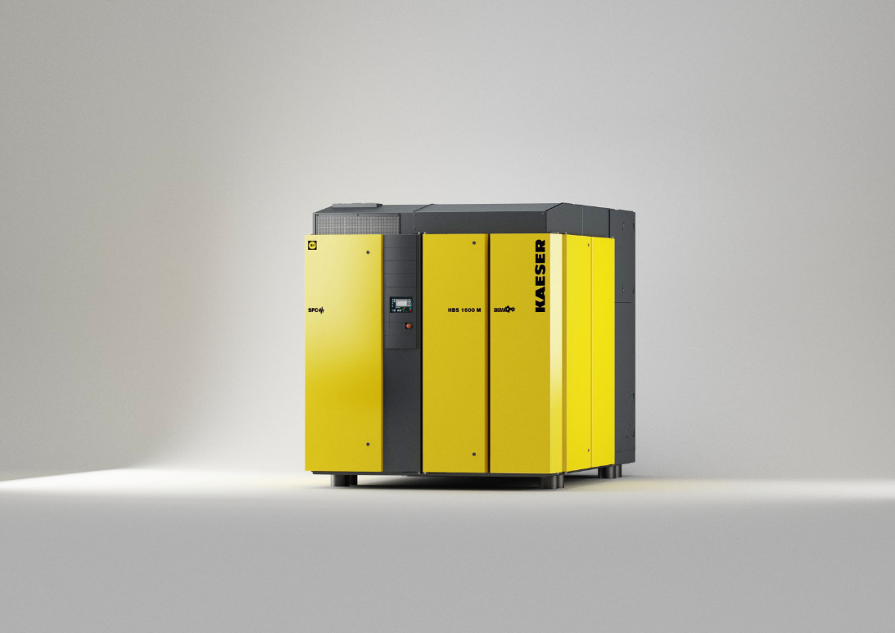
012_Image 1_Kaeser HBS_1600_M_SFC.jpg
Caption: HBS screw blowers set a new benchmark in compressor technology for the 132 to 250 kW power range, with flow rates from 60 to 160 m³/min and differential pressures up to 1100 mbar.

((Kaeser photo – free for publication))

