March 2020
Specialised applications require specialised products

Salmon aquaculture – using sea pens to farm salmon – is a booming segment of the food industry. Profit margins are ever high, as is consumer demand. This has led to the increasing use of technology by the aquaculture industry, much of which relies on the use of compressed air. Salmon feeding has already been a pneumatic procedure for over 12 years, whereby the feed is directed from the feed silo into the pens by a low-pressure air stream. This tried-and-tested technique is now leading to feed barges being designed with machine rooms beside the feed silos, in which the blowers can be housed to protect them from the outside elements.

In recent years, higher pressure compressed air applications have increasingly found their way into the aquaculture industry. Operating in the 7 bar range, compressors – either diesel or electric powered – are used to provide the compressed air for such tasks as removing dead fish from the pens (morts removal), or to raise the level of oxygen in the sea pens, a procedure known as “Sea Pen Aeration”.

Prior to this innovation, divers had to be dispatched to the pens to manually place the dead fish in baskets, which then had to be lifted out of the water by hand. Now, using compressed air to do the job instead, a cone is installed in the deepest part of the sea pens. This is connected to a tube through which compressed air is blown, forcing the dead fish up from the bottom of the pen to the top, owing to the “airlift pump” principle. Here they are separated from the water so that the staff can assess the condition of the carcasses and conduct statistical analyses on them.
This is far quicker and less labour-intensive than the previously used manual approach, and removal of the carcasses sooner rather than later also helps prevent the spread of disease. A recent further development to the idea of extracting the carcasses in this way is to do the same with faecal matter. This concept is already being tested in closed pens on test farms and could be used in future in areas where both water quality and environmental impact are of key concern.
Sea Pen Aeration and compressed air
One of the most important uses for compressed air in aquaculture is “Sea Pen Aeration” (SPA), a process whereby compressed air is blown into the pens through diffusers. As bubbles rise to the surface, a gas exchange takes place between the water and the gases in the bubbles, raising the oxygen levels in the water. Even more importantly, it results in an artificial upwelling, which forces oxygen-rich, cold water from deeper down in the water column up into the pens.
This has several effects: firstly, because colder, deep waters can hold more oxygen, the oxygen levels in the pens are raised. This is particularly important in the summer months, when environmental factors such as algal blooms can be a major concern. Cold, deep waters also mitigate the effects of temperature peaks, which are dangerous for the salmon and have become increasingly common during the summer months in recent years. A further effect of the upwelling is that, thanks to the water at the upper levels flowing outwards, less of the oxygen-poor surface water enters the pens. Moreover, algae drifting in upper water layers are kept out of the sea pens by the outwards flow. This effect is most important during algae blooms and prevent the algae from reaching the Salmon.

The SPA concept described above is used most commonly in Canada and Norway. In other countries, such as Chile or Scotland, bubble curtains are the usual method for protecting the fish from swarms of jellyfish (Scotland) and algal blooms (Chile). In the past, these two blights have been responsible for wiping out entire fish stocks in some farms and have caused damages in the millions.

Such compressor applications are completely new, so most feed barges have nowhere to house the associated necessary equipment. This means that the compressors tend either to be installed at the farms themselves, or on rafts built especially to accommodate them.

Compressors with electric drive motors are usually housed within a container, whereas diesel-powered compressors are generally left exposed to the elements. Both types of compressor, however, were designed for use on land; the harsh conditions found at sea, with constant exposure to saltwater, were not part of the design brief. This weak link in the design chain has led to premature problems occurring with compressor operation, particularly under the tough operating conditions associated with maritime use. However, compressors are essential to protect farms against such existential threats as jellyfish swarms, algal blooms or other potentially critical dangers in an emergency. For this reason, downtime due to failure of the electrical system, for example, is unacceptable and operational reliability is paramount.

Meeting the specialist needs of aquaculture
It was Thomas Kaeser himself, Chairman of the Board at Kaeser Compressors, who recognised the special needs of the aquaculture industry and therefore commissioned an aquaculture specialist to examine the specific issues at hand. The company subsequently spent 2018 becoming intensely acquainted with the aquaculture sector. It looked at the problems compressors face in this difficult operating environment, analysed the key aquaculture markets and liaised closely with fish farmers and plant hire companies.

Equipped with this knowledge, Kaeser Compressors was able to develop the first prototype of a compressor that was designed specifically for use in the aquaculture industry. Introduced to the world at the AquaSur 2018 trade fair in Chile, this ground-breaking innovation was built to withstand maritime environments and to ensure maximum operational reliability. Through continuous consultation with end customers, this prototype has been further refined so that Kaeser Compressors can now offer a compressor configuration which delivers even greater reliability under the harsh conditions that go hand-in-hand with aquaculture applications. This, in combination with increased compressor service life, means that plant hire companies and fish farmers alike can enjoy the significant advantages that Kaeser compressed air solutions have to offer.

Kaeser compressors and blowers are renowned throughout the world for their high quality, outstanding reliability and exceptional energy efficiency. For more information visit nz.kaeser.com or phone 0800 447 820.
-END- Free for publication, copy appreciated
Editors Notes
From 0.18 to 515 kW, Kaeser Compressors manufactures a wide range of compressors and associated auxiliary equipment that meet the varying requirements of a diverse range of industries and applications.

One of the world’s largest manufacturers of rotary screw compressors, Kaeser Compressors is represented globally in over 100 countries through a dedicated network of branches, subsidiary companies and authorised partners.

Kaeser Compressors NZ Limited provides comprehensive air compressor and blower sales and service throughout New Zealand from its offices in Auckland, alongside a dedicated and nationwide network of authorised partners.

For editorial and advertising enquiries contact: Beth Wood, Marketing Manager
Press office: +61 3 9791 5999 Fax: +61 3 9791 5733
E-mail: beth.wood@kaeser.com

KAESER COMPRESSORS NZ Limited
18B Tarndale Grove, Albany, Auckland 0632, New Zealand
Phone: +64 9 941 0499 Email: info.newzealand@kaeser.com
nz.kaeser.com

File: N-Aquaculture-Technical-Article-nz
Approved for publication, copy acknowledgement appreciated
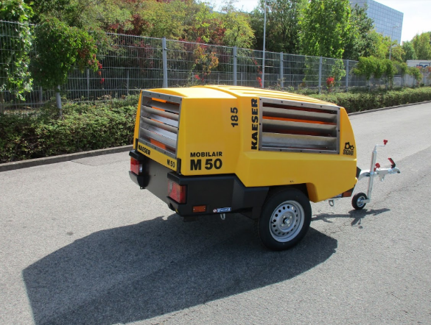
Caption: Prototype of the diesel powered Kaeser M 50 including aquaculture modifications

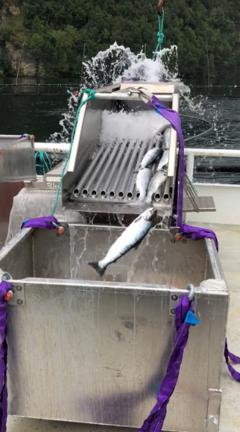
Caption: Separation of carcasses and water in the morts removal process.

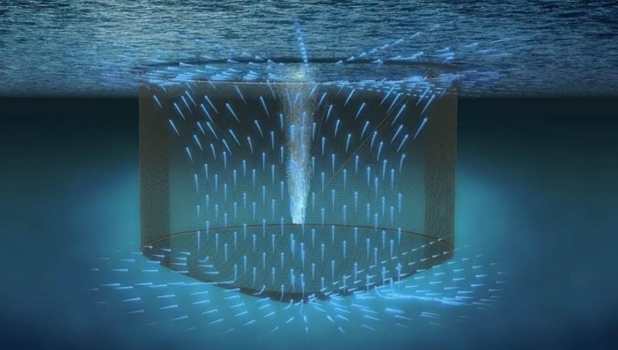
Caption: Operating principle of the SPA system [Source: Pentair Aquatic Eco-Systems]

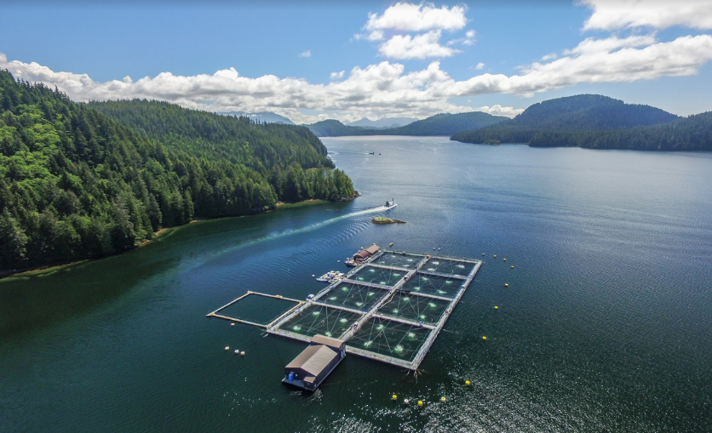
Caption: A Sea Pen Aeration system in full operation at a salmon farm site. Note: Four plumes of aeration inside each pen. [Source: Pentair Aquatic Eco-Systems]

Kaeser photo(s) – free for publication, credits appreciated.

