Kaeser supplies Shotcrete Auckland with a reliable supply of portable compressed air
Shotcrete Auckland recently invested in a Kaeser Mobilair 100 portable compressor, in order to generate a reliable supply of high quality compressed air required for the shotcrete process the company utilises in spraying concrete for its customers.
From architectural and landscape constructions to ground support, roads, bridges and dams; shotcrete is a versatile process used to lay concrete for numerous applications.
Shotcrete Auckland is the largest shotcrete firm in New Zealand and has over 30 years of experience in the field. The only company in New Zealand that is internationally certified by the American Shotcrete Association, Shotcrete Auckland recently invested in a Kaeser Mobilair 100 portable compressor to assist in the reliable spraying of concrete using the shotcrete process.
Shotcrete is a versatile process able to lay concrete horizontally, vertically or even overhead. The cement mixture is pumped through a hose and then pneumatically sprayed onto a surface. The velocity with which the cement leaves the nozzle allows for the concrete to be compacted at the same time.
Compressed air is an integral part of the shotcrete process, increasing the velocity at which the concrete leaves the nozzle. A reliable supply of high quality air is essential to achieving a high shotcrete velocity and good compaction. This ensures denser concrete that will be less permeable and have a greater compressive strength.
Recognising the requirement for a reliable source of high quality compressed air, Glenn Tira, the Director of Shotcrete Auckland called upon their existing supplier Blueprint Diesel for a solution.
Kaeser partner Blueprint Diesel recommended the Kaeser Mobilair M 100 portable compressor to meet these requirements. Part of the renowned Mobilair range of portable compressors from Kaeser, the Mobilair 100 provides exceptional power and versatility.
Like all other portable compressors in the Mobilair range, the M 100 includes a Kaeser rotary screw compressor block equipped with energy-saving Sigma Profile rotors. All components found in the M 100 have been manufactured to the highest standards. Along with precision aligned roller-bearings this ensures long service life with maximum reliability.
In addition, Mobilair portable compressors are simple to operate, provide excellent component accessibility and are easy to maintain.
Shotcrete Auckland subsequently acquired an M 100. Glenn said 'Blueprint Diesel was great in finding the perfect compressor to meet our unique needs. We have been very impressed with the Mobilair 100. It is doing exactly what we require!'
Manufactured at Kaeser's state-of-the-art production facility located in Coburg, Germany, the Mobilair M 100 is available with a 71.7 kW drive motor, standard working pressures from 7 to 14 bar with free air deliveries from 6.4 to 10.2 m³/min.

File: Q-shotcrete-nz
Approved for publication, copy acknowledgement appreciated
Images: (contact the press office for high res copies of the following images)

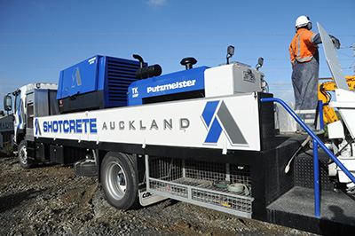
Caption: Shotcrete Auckland is the largest shotcrete firm in New Zealand

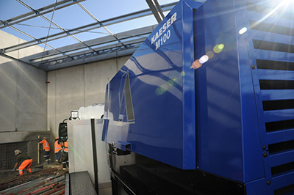
Caption: Shotcrete Auckland recently invested in a Kaeser Mobilair 100 portable compressor

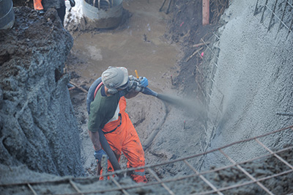
Caption: The cement mixture is pumped through a hose and then pneumatically sprayed onto a surface

