October 2019

Kaeser expands into Lower North Island

Kaeser Compressors has recently expanded its direct operations, now providing sales and service support throughout Lower North Island including Palmerston North and Wellington.

Celebrating it centenary in 2019, German manufacturer Kaeser Compressors has been present in the New Zealand market now for almost 30 years. Strong growth in the region led Kaeser to establish a dedicated subsidiary five years ago. With its head office in Auckland, and alongside an extensive network of Authorised Sales and Service Centres, Kaeser Compressors NZ Limited provides comprehensive sales and service throughout New Zealand.

Kaeser recently expanded its direct operations and now provides premium quality compressed air sales and local service support throughout Lower North Island – including Palmerston North and Wellington – the surrounding Manawatu-Wanganui district and into the Wairarapa.

Premium service plays a key role in ensuring that a compressed a system operates at its peak performance and provides maximum production reliability. Compressed air users in Lower North Island can be assured that whatever the make or model of their air compressor, when they choose Kaeser they will receive premium service support. And, for existing Kaeser compressor owners in the area, it is worth remembering that only current authorised Kaeser Service Technicians are factory training with the most up-to-date information and skills to service Kaeser compressed air equipment. And, they will only ever use genuine maintenance and spare parts with proven durability for unrivalled reliability and long service life.

For more information visit nz.kaeser.com or phone 0800 447 820.
-END-
Editors Notes
From 2.2 to 500 kW, Kaeser Compressors manufactures a wide range of compressors and associated auxiliary equipment that meet the varying requirements of a diverse range of industries and applications.

One of the world’s largest manufacturers of rotary screw compressors, Kaeser Compressors is represented globally in over 100 countries through a dedicated network of branches, subsidiary companies and authorised partners.

Kaeser Compressors NZ Limited provides comprehensive air compressor and blower sales and service throughout New Zealand from its offices in Auckland, alongside a dedicated and nationwide network of authorised partners.

For editorial and advertising enquiries contact: Beth Wood, Marketing Manager
Press office: +61 3 9791 5999 Fax: +61 3 9791 5733
E-mail: beth.wood@kaeser.com

KAESER COMPRESSORS NZ Limited – 18B Tarndale Grove, Albany, Auckland 0632, New Zealand
Phone: +64 9 941 0499 – https://nz.kaeser.com – E-mail: info.newzealand@kaeser.com

File: O-lower-north-island-nz
Approved for publication, copy acknowledgement appreciated
Images:

((Captions)) :

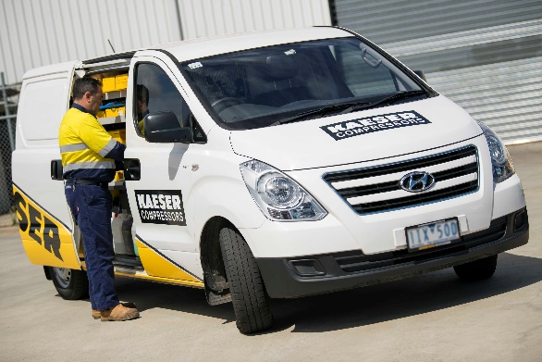
022_Image 1_Kaeser service technician.jpg
Caption: Kaeser delivers premium service support throughout NZ

((Kaeser photo – free for publication))

