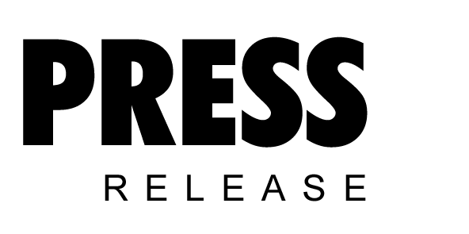

June 2019

Kaeser at the Water NZ Conference & Expo 2019: discover tomorrow’s technology today

Visitors to stand 140 at the Water NZ Conference & Expo 2019, will be able to learn more about Kaeser Compressors’ innovative, extremely efficient and future orientated compressor and blower solutions which are ideally suited to water- and wastewater-treatment applications. This includes the Sigma Air Manager 4.0 - a key technology in the advanced world of Industrie 4.0.

The Sigma Air Manager 4.0 (SAM 4.0) from Kaeser brings users ever closer to Industrie 4.0 applications, which enables optimal coordination and control of all components within a compressor or blower station to meet the customer's exact requirements. The real-time gathering, transmission and management of in-process operating data enables users to anticipate faults and act promptly before they occur.

SAM 4.0 is at the core of a compressor or blower station and is the key technology for opening up access to the services that Industrie 4.0 has to offer. As the central controller, SAM 4.0 controls the various machines in its control for optimum efficiency, and precisely matches air delivery with the required airflow profile. Within seconds it analyses the operating data, simulates possible responses and selects the most efficient alternative. The result: an entirely new level of energy efficiency.

With the greatest of ease the SAM 4.0 can also display and analyse pressure data, air delivery, performance, maintenance messages and any fault messages, past or present. The network connection also offers the convenience of working with this data on a PC. Aside from providing peace of mind and enabling predictive maintenance, this permits energy management in compliance with ISO 50001.

Multi-device control additionally opens up new possibilities for the advance planning of compressor or blower maintenance. In the past, maintenance was possible only when fault messages occurred or as part of scheduled servicing. With SAM 4.0, it is now possible to initiate maintenance work before faults occur, helping to avoid downtime and the further damage that faults may cause.

The onboard sensors in the Kaeser machines, and the Sigma Control 2 compressor control system, collect process data and forward it to the SAM 4.0 in real time. With special software, the data is then forwarded to the Kaeser Data Center and subjected to real-time analysis. The Kaeser Data Center performs central monitoring and handles system messages, initiating predictive maintenance measures as needed. As a result, maintenance can be carried out at the precise time when it is needed. This saves time and expense and ensures maximum blower or compressor availability - and therefore the processes that they support.

Visitors to stand 140 at the Water NZ Conference & Expo 2019 will be able to experience the SAM 4.0 first hand, as well as learn about other energy efficient and future orientated compressor and blower solutions that Kaeser has to offer. Join Kaeser at the Water NZ Conference & Expo 2019 on stand 140, 18-20 September at Claudelands, Hamilton. For more information visit www.kaeser.co.nz or phone 0800 447 820.
-END-
Editors Notes
From 2.2 to 500 kW, Kaeser Compressors manufactures a wide range of compressors and associated auxiliary equipment that meet the varying requirements of a diverse range of industries and applications.

One of the world’s largest manufacturers of rotary screw compressors, Kaeser Compressors is represented globally in over 100 countries through a dedicated network of branches, subsidiary companies and authorised partners.

Kaeser Compressors NZ Limited provides comprehensive air compressor and blower sales and service throughout New Zealand from its offices in Auckland, alongside a dedicated and nationwide network of authorised partners.

For editorial and advertising enquiries contact: Beth Wood, Marketing Manager
Press office: +61 3 9791 5999 Fax: +61 3 9791 5733
E-mail: beth.wood@kaeser.com

KAESER COMPRESSORS NZ Limited – 18B Tarndale Grove, Albany, Auckland 0632, New Zealand
Phone: +64 9 941 0499 – www.kaeser.co.nz – E-mail: info.newzealand@kaeser.com

File: o-Water-NZ-2019-preview-nz
Approved for publication, copy acknowledgement appreciated
Image:
((Captions)) :

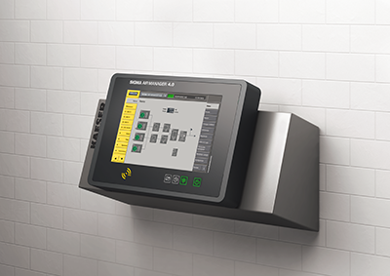

Caption: Visitors to stand 140 at the Water NZ Conference & Expo 2019 will be able to experience the SAM 4.0 first hand.

((Kaeser photo – free for publication))

