SAM 4.0: Tomorrow’s technology today

Industrie 4.0, or the ‘Internet of Things,’ promises to be a far-reaching revolution in production. The new Sigma Air Manager 4.0 (SAM 4.0) makes it all possible: the ability to make predictions far in advance, know today what the future holds, network components and exploit much larger data volumes than ever before – whilst also ensuring significant energy cost savings and delivering a reliable, consistent and efficient compressed air supply.
The latest generation of the Sigma Air Manager (SAM 4.0) - the master control system for all of your compressed air production and treatment components – is now available. Amongst many other key benefits, the new system optimises pressure values, automatically adjusts compressor system air delivery to accommodate fluctuating air demand and optimises system efficiency through constant analysis of the relationship between control losses, switching losses and pressure flexibility. Moreover, the SAM 4.0 enables your compressed air station to take advantage of future services such as predictive maintenance. All of these features not only boost operational reliability and efficiency, but also significantly reduce energy costs.
Best possible pressure quality, tailored to specific needs.
This is in no small part made possible by Kaeser’s adaptive 3-D advanced Control, which takes into account additional factors - aside from switching losses (start/stop) - that influence compressed air system energy efficiency. These include control losses and idling, frequency converter operation and pressure flexibility (average increase above required pressure). This innovative control strategy predictively calculates the optimum achievable configuration and adjusts the connected components accordingly – all based on the specific pressure required by the user.
When machines talk
The SAM 4.0 supports operation in 30 languages, while the easy-to-use 12-inch colour touchscreen shows at a glance whether the station is operating in the “green zone” from an energy management perspective. Operating status, pressure history, free air delivery, power consumption, as well as maintenance and any error messages can be easily displayed and analysed – both in real-time and retroactively. Using a PC and network connection, this data can be accessed conveniently from anywhere, not just at the machine itself. This not only provides users with peace of mind, but also lays the foundation for predictive maintenance and enables energy management in accordance with ISO 50001.
Sigma Network
The far-reaching benefits of the SAM 4.0 are expanded even further when users also take advantage of Kaeser’s Sigma Network. Based on Ethernet technology, the powerful Sigma Network is a closed and secure network that has been specially developed to support optimal monitoring and coordinated control of compressed air stations.
Remote diagnostics and predictive maintenance
The SAM 4.0 offers additional powerful features. For example, maintenance and error messages can be immediately sent via email to a pre-set personal address and the remote diagnostics option allows for predictive maintenance and service based on actual use. Both of these elements increase compressed air availability and reliability and also help keep lifecycle costs to an absolute minimum.
SAM 4.0: Future-ready
The SAM 4.0 is ready-designed to accommodate potential future compressed air system expansion. A straightforward software upgrade allows for expansion with no need for additional investment in new hardware

File: m-Sigma Air Manager 4.0-nz
Approved for publication, copy acknowledgement appreciated
Image:

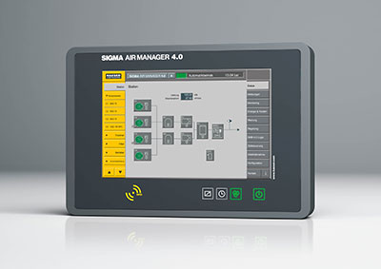
SAM 4.0: The Sigma Air Manager 4.0 (SAM 4.0) not only ensures highly efficient monitoring and control of all compressed air station components, but also enables them to take advantage of the future-oriented benefits that Industrie 4.0 has to offer.

