"CBC": Turn-key rotary blowers with integrated power supply equipment
Save money even before commissioning
Kaeser’s “CB 111 C” and “CB 131 C” rotary blowers are supplied connection-ready with integrated mains power supply equipment and monitoring. They deliver from 4.7 to 12.5 m³/min at up to 1000 mbar (g) or 500 mbar (partial vacuum). Key applications for these new blowers include pneumatic conveying of powdered goods, water treatment and generation of blowing air.
These new blowers can be supplied ready for operation including all sensors and star-delta starter, or with frequency converter for flexible speed control. The complete system packages are CE and EMC certified, which means less work for both the operator and system provider when it comes to planning, installation, certification, documentation and commissioning. A range of motors is also available to accommodate various performance requirements, whilst noise and pulsation reduction measures ensure quiet operation at all times.
As one would expect from an industry leader such as Kaeser Compressors, these innovative rotary blower systems are based on inherently intelligent design: System operators not only benefit from significant energy and operational cost savings, but are also able to take advantage of considerable savings for installation, planning, commissioning and certification. The blowers also provide exceptional reliability and availability.
Moreover, their space-saving component layout results in an exceptionally compact footprint. Also, as these blowers have been designed to allow all service work to be carried out from the front of the unit, it is possible to install several blowers side by side. Components such as control valves, which would normally be installed externally, are incorporated into the equipment and are controlled via the blower’s internal “Omega Control” controller. Planning, installation and documentation of centralised blower stations is therefore made even simpler.
Of course, operating costs do not just depend on the efficiency of the individual components within the station. Various other factors play a key role, such as actual pressure and air demand, selection of appropriate and suitably matched blowers and drive systems, as well as tailored sequencing control. This is where an Air Demand Analysis (ADA) can prove invaluable: With help from such detailed analysis it is possible to determine how compressed air demand varies over time, how efficiently a blower station is operating, and to what extent availability and efficiency can be further enhanced. The “Kaeser Energy Saving System” (KESS) is another powerful optimisation tool. This specialised planning software enables different system variants to be simulated and compared with one another, and their respective potential savings to be calculated. Transparency of future servicing and maintenance costs is also essential when considering the total life cycle costs of both individual blowers and stations as a whole. Needless to say, this task requires the kind of knowledge and expertise that only an experienced compressed air system provider such as Kaeser Compressors can offer.
By choosing Kaeser, planners and operators not only profit from all of the advantages that Kaeser's latest generation of blowers deliver, but also benefit from the company's decades of experience in system planning and optimisation. As a result, they can enjoy the rewards of enhanced system efficiency and maximum dependability.

File: h-cbc-nz
Approved for publication, copy acknowledgement appreciated
Image:

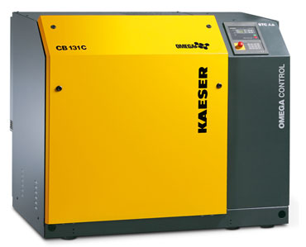
Kaeser’s CBC series rotary blowers combine intelligent design with exceptional efficiency and dependability. Their access-friendly configuration enables side-by-side installation of multiple units.

