Join the Kaeser Network

Fast, secure and future-ready! The powerful Ethernet-based Sigma Network developed by Kaeser Compressors, provides optimised compressed air station monitoring and control. In addition, the Kaeser Sigma Network is able to take advantage of the future-oriented benefits that Industry 4.0 has to offer.
Industrial applications place special demands on communications - including machine to machine communication - and this forms the basis of Industry 4.0. Such communication technology must not only be durable and easily manageable onsite, but it should also be globally compatible, fast and secure, with the ability to transfer large volumes of data with maximum integrity. The Kaeser Sigma Network meets all of these needs and more...
Based on secure Ethernet technology, the future-ready Kaeser Sigma Network is a local network within the compressed air station that enables optimised integration of a station's components. Unlike current field-bus solutions, such as Profibus, CAN or similar technologies that operate at relatively slow speeds (max. 12 Mbit/s), the Kaeser Sigma Network has a transfer speed of 100 Mbit/s. The widely accepted TCP/IP protocol standard - also recognised as the Lingua Franca of the Internet - forms the basis for data traffic in the Kaeser Sigma Network.
The Kaeser Sigma Network uses Kaeser-own MAC addresses and creates a closed and secure network segment in accordance with the recommendations for industrial control systems. A defined transfer node enables secure data exchange with external partners.
Working in perfect harmony with the Kaeser Sigma Air Manager (SAM 4.0) PC-based master compressed air management system, the Kaeser Sigma Network forms an infrastructure that makes data available for future services, such as predictive maintenance or energy management.
This not only reduces cost, but also increases operational reliability and availability. If required by the user, operational data from the compressed air station can be securely transferred to the Kaeser Data Centre via a broadband connection. This allows Kaeser experts to perform remote diagnostics and enables predictive and demand-oriented maintenance. For the user this translates into maximum supply dependability as well as lowest possible life-cycle costs, since Kaeser's compressed air specialists are able to adjust the energy characteristics of the compressed air station as required, ensuring the station performs at maximum efficiency at all times.

File: m-Kaeser-network-nz
Approved for publication, copy acknowledgement appreciated
Image:

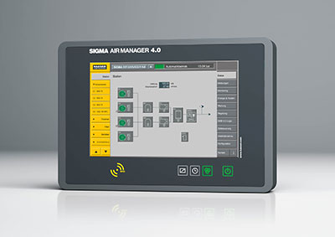
The powerful Kaeser Sigma Network provides optimal compressed air station monitoring and control as well as providing advanced Industry 4.0 operational capability

