July 2021

Local stock and proven reliability:
Kaeser delivers Golden Bay Cement with an expedient and reliable compressor solution

When an existing compressor in an established system becomes unreliable or fails, a swift solution is required. This was a key reason why leading cement manufacturer Golden Bay Cement, recently invested in a Kaeser DSDX 305 series rotary screw compressor for its manufacturing plant in Portland, Whangarei.

From DIY projects to pavements, industrial buildings, retail stores and car parks, you will find Golden Bay Cement products in use - and being used for a wide range of applications - throughout New Zealand. The longest standing cement manufacturer and supplier in New Zealand, Golden Bay Cement is also the country’s only fully integrated manufacturer of cement. This means that it quarries the raw materials used to make cement, right through to manufacturing the finished cement powder.

Compressed air is an essential utility required throughout the cement manufacturing process, from facilitating the flow of materials from start to finish, to assisting with the actual manufacturing process itself.
As such an integral component of the cement manufacturing process, compressed air reliability is essential. So when one of the base load compressors became unreliable and eventually failed, Aaron Polwart the Machinery Health Technician & Air Services Section Engineer at Golden Bay Cement needed a prompt solution.

An expedient and reliable compressor solution
Golden Bay Cement considered a number of options including repairing the existing compressor. In the end the most cost effective and expedient solution was to replace the compressor with a new one. Having already got two Kaeser compressors onsite working reliably, Kaeser was one of the suppliers contacted for a solution. With a suitably sized compressor in stock locally, a Kaeser DSDX 305 series rotary screw compressor was therefore selected and installed at Golden Bay Cement.

Designed for optimum efficiency, the DSDX series rotary screw compressors from Kaeser provide energy savings as standard. In the latest generation models, the flow-optimised Sigma Profile rotors have been further refined, providing the basis for exceptional energy efficiency.

The use of high performance IE4 drive motors further maximises energy efficiency. These motors not only comply with - but - exceed prevailing New Zealand EECA regulations for 3 phase electric motors, and Kaeser is currently the only compressed air systems provider to equip some of its compressors with IE4 drive motors. For the end user this translates into best possible compressor performance, reduced energy costs and significantly enhanced compressed air production efficiency. In addition efficiency is enhanced with Kaeser’s 1:1 drive design. As the motor directly drives the airend, transmission losses associated with gear or V-belt driven systems are eliminated.

An intelligent component layout also contributes to the energy efficiency of these compressors. For example, all service and maintenance points are within easy reach and directly accessible from the front of the unit. This not only saves time and money, but also maximises compressed air system availability.

Last, but not least, the advanced and integrated Sigma Control 2 compressor controller achieves additional energy savings and minimises cost-intensive idling periods through the use of a variety of specially developed control options.

Conclusion
The DSDX 305 series rotary screw compressor has now been in operation at the plant for over 12 months, and forms part of the common ring main that supplies the whole plant with compressed air.

Polwart concluded: ‘Thus far we’re really happy with the performance and reliability of the Kaeser DSDX compressor. From an operational perspective it's easy to use and it’s already proving to require less maintenance.’

The DSDX series of rotary screw compressors from Kaeser Compressors are available with drive powers of 132 and 160 kW, and produce flow rates from 4.8 to 34.25 m³/min, pressure 7.5 to 15 bar. For more information visit nz.kaeser.com or phone 0800 447 820.
-END- Free for publication, copy appreciated
Editors Notes
From 0.18 to 515 kW, Kaeser Compressors manufactures a wide range of compressors and associated auxiliary equipment that meet the varying requirements of a diverse range of industries and applications.
One of the world’s largest manufacturers of compressors, blowers and compressed air systems, Kaeser Compressors is represented throughout the world by a comprehensive network of branches, subsidiaries and authorised distribution partners in over 140 countries.
Kaeser Compressors NZ provides comprehensive sales and service throughout New Zealand, from its facility in Auckland, alongside an extensive network of authorised partners.

For editorial and advertising enquiries contact: Beth Wood, Marketing Manager
Press office: +61 3 9791 5999 Fax: +61 3 9791 5733
E-mail: beth.wood@kaeser.com

KAESER COMPRESSORS NZ Limited
18B Tarndale Grove, Albany, Auckland 0632, New Zealand
Phone: +64 9 941 0499 Email: info.newzealand@kaeser.com
nz.kaeser.com
File: Q-Golden-Bay-Cement-nz
Approved for publication, copy acknowledgement appreciated
Images:
Contact our press office for high res versions (beth.wood@kaeser.com)
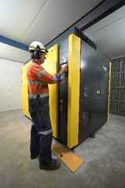
Caption: The Kaeser DSDX 305 series rotary screw compressor at Golden Bay Cement’s manufacturing plant in Portland, Whangarei.

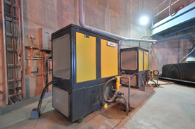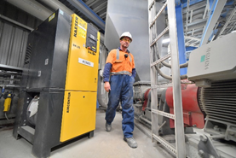

Caption: The existing Kaeser compressors that were already onsite and working reliably at Golden Bay Cement.

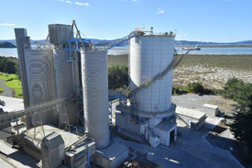

Caption: The Golden Bay Cement manufacturing plant in Portland, Whangarei.

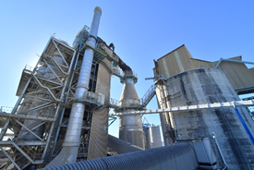
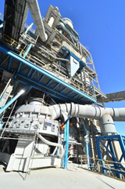

Caption: Compressed air is an essential utility required throughout the cement manufacturing process, from facilitating the flow of materials from start to finish, to assisting with the actual manufacturing process itself. Pictured above the PHT tower and conditioning towers.
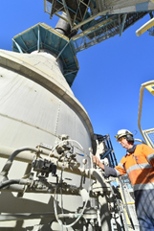

Caption: Compressed air is an essential utility required throughout the cement manufacturing process, from facilitating the flow of materials from start to finish, to assisting with the actual manufacturing process itself. Pictured above water spray nozzles.

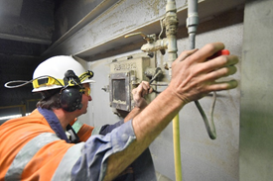

Caption: Compressed air is an essential utility required throughout the cement manufacturing process, from facilitating the flow of materials from start to finish, to assisting with the actual manufacturing process itself. Pictured above viewing point towards the back end of the cooler.

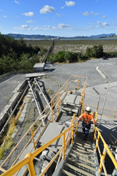

Caption: Compressed air is an essential utility required throughout the cement manufacturing process, from facilitating the flow of materials from start to finish, to assisting with the actual manufacturing process itself. Pictured above point of discharge from the Bulk Finished Product Silos.
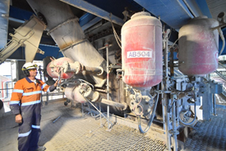

Caption: Compressed air is an essential utility required throughout the cement manufacturing process, from facilitating the flow of materials from start to finish, to assisting with the actual manufacturing process itself. Pictured above some air cannons.

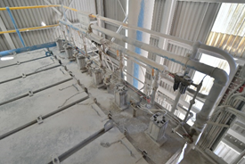

Caption: Compressed air is an essential utility required throughout the cement manufacturing process, from facilitating the flow of materials from start to finish, to assisting with the actual manufacturing process itself. Pictured above some dust collectors.

Kaeser photo(s) – free for publication, credits appreciated.

