May 2024

Mobilair M27PE portable compressor:
Easy to operate. Easy to transport. Easy to service.

A mainstay for any portable compressor rental fleet, the Mobilair M27PE from Kaeser Compressors, is a true powerhouse that is easy to operate, easy to transport and easy to service. With a number of options available, this versatile portable compressor can effortlessly turn its hand to numerous applications in industries such as fibre optics and trenchless construction.
From fibre optics, to underground piercing and trenchless construction, to dry ice and bead blasting, there are numerous applications for the Mobilair M27PE portable compressor. With flow rates up to 2.6 m³/min, and working pressure up to 14 bar, it can power two 20 kg breakers, or other tools such as air lances, spades, impact borers and sandblasting equipment. And, when specified with the optional maintenance-free 6.5 kVA generator (IP54), the M27PE is transformed into a portable power plant, capable of providing compressed air and/or electricity as required.

At the heart of the M27PE series portable compressor lies the Sigma Profile screw compressor block. Developed by Kaeser some years ago and continuously enhanced ever since, it achieves power savings of up to 15 percent compared with conventional screw compressor block rotor profiles. This contributes to the overall high efficiency of these compressors. Designed for continuous operation it is driven by a powerful, water-cooled Kubota diesel engine.

Operation is made simple thanks to the single start switch and easy-to-understand icons, ensuring every new customer can manage it easily with simple start and operating procedures. Furthermore, a 40 litre fuel tank holds sufficient diesel for long work shifts without the need for refuelling.

All M27PE model variants weigh 625 kg or less. With height-adjustable or fixed tow bar versions available, they are easy to manoeuvre and transport even for smaller towing vehicles.

For maximum compressed air availability, the wide-opening enclosure provides excellent access to all maintenance-relevant components, making service work a breeze. Whats more, Kaeser Compressors NZ has a nationwide network of factory trained Service Technicians available 24-7 for emergency service support.

The durable and resilient M27PE portable compressor, features a polyethylene enclosure (PE), assuring impressive impact resistance even in adverse operating conditions. Corrosion and scratch proof, this modern canopy contributes to the compressor looking smart for many years to come, as well contributing to its long-term value retention. The canopy can also be supplied in a number of colours, keeping your Mobilair fleet on brand!

For optimum versatility and to meet a wide range of application requirements, a number of options are available with the M27PE, such as compressed air treatment, a hose reel, and a toolbox for convenient storage of work tools.

With a long life and high residual value, the flexible Mobilair M27PE is a mainstay for any portable compressor fleet.

Limited quantity special offer

Kaeser Compressors NZ is currently offering a limited quantity of its M27PE portable air compressors at a special discounted sale price. For more information visit nz.kaeser.com or phone 0800 447 820.
-END-
Editors Notes
Kaeser Compressors is one of the world’s leading compressor manufacturers and compressed air system providers, represented internationally by a comprehensive network of subsidiaries and authorised distribution partners in over 140 countries.
Kaeser’s comprehensive product range comprises; reciprocating and rotary screw compressors ranging from 0.18 to 515 kW, portable rotary screw compressors, high-pressure and dry-running compressors, compressor control systems, vacuum pumps, rotary blowers, rotary screw blowers, turbo blowers, air filters, refrigeration & desiccant dryers, as well as compressed air system accessories and services.

Established in 2015, Kaeser Compressors NZ Limited, provides comprehensive sales and service throughout New Zealand, from its facility in Auckland, alongside an extensive network of authorised partners.

For editorial and advertising enquiries contact:
Press office: +64 9 941 0499 E-mail: marketing.nz@kaeser.com

KAESER COMPRESSORS NZ Limited
18B Tarndale Grove, Albany, Auckland 0632, New Zealand
Phone: +64 9 941 0499 Email: info.newzealand@kaeser.com Web: nz.kaeser.com

Images:
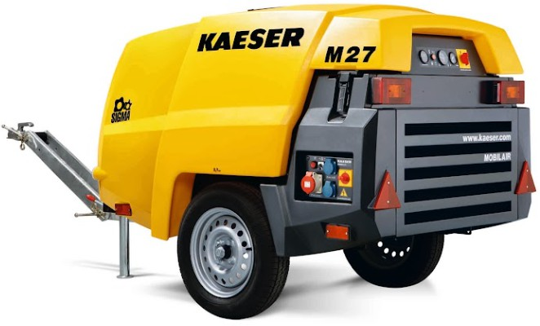

002_Image 1_KAESER M27PE.jpg
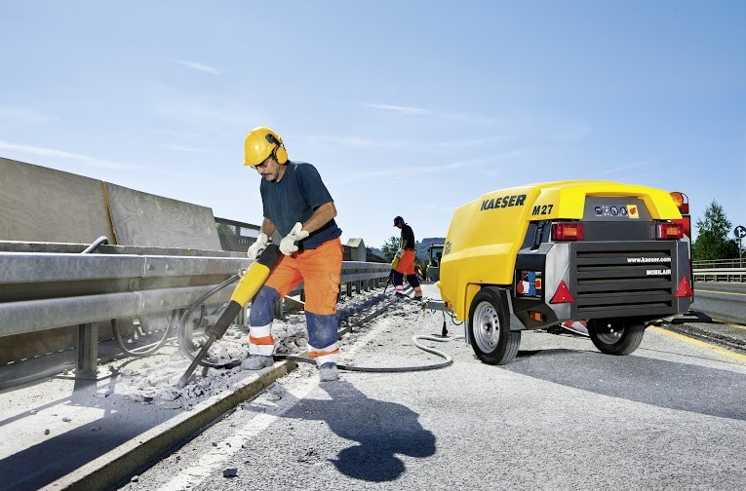
002_Image 2_KAESER M27PE_construction.jpg

Caption: The Mobilair M27PE delivers impressive performance with a wide range of equipment options for maximum flexibility.

((Kaeser photo – free for publication))

