January 2021

The perfect fit!
Kaeser reliably meets Mongrel Boots increased demand for compressed air
Mongrel Boots manufacturer Victor Footwear, recently opted for a Kaeser BSD 65 T series rotary screw compressor with integrated refrigeration dryer to reliably meet the increased compressed air requirements of its latest direct injection moulding machine, which is used to directly inject the advanced dual density soles of all Mongrel Boots directly onto an upper.
Established in 1930, Victor Footwear is a fifth-generation family owned and operated Australian footwear manufacturer responsible for the truly ‘Aussie Born and Bred’ Mongrel Boots brand of safety and non-safety work boots.
Whether you prefer a lace up, an elastic side or a ZipSider (which the company was first to create back in 2006) - with over 45 styles of safety and non-safety work boots to choose from, you’re sure to find a pair of Mongrel Boots that fit!
Every pair of Mongrel Boots remains proudly designed and manufactured at the company’s purpose-built factory in Sydney, Australia. Here Victor blends an old school attitude for workmanship with the latest technology and innovation, in order to deliver each customer with the most perfectly engineered boot for the job at hand.

Utilising advanced technology
Compressed air is an essential utility required in many stages of the manufacturing process at Victor. This includes powering a lot of the production machinery used to produce the footwear uppers and soles such as the lasting machines - which draws, stretches and bends the upper of the boots.
Another key piece of production machinery that depends on a reliable supply of compressed air to operate, are the direct injection moulding machines. Representing the latest and most technically advanced method of attaching soles to footwear uppers - here the advanced dual density soles of all Mongrel Boots are directly injected onto an upper.
Victor recently invested in a new 30 station Desma direct injection moulding machine in order to be able to keep up with growing demand. Adding this additional machinery to the factory meant that the compressed air requirement would also increase. To ascertain whether the existing compressed air system could meet this increased demand or any additional compressed air equipment may be required, Victor contacted their long-standing compressed air partner - Kaeser Compressors - for a solution.
After assessing the new compressed air requirements that the additional direct injection moulding machine would create, Kaeser recommended and subsequently installed a BSD 65 T series rotary screw compressor with integrated refrigeration dryer.
A reliable and efficient solution
With its latest generation of BSD series rotary screw compressors, Kaeser pushes the boundaries of compressed air availability and efficiency even further. Not only do they deliver more compressed air for less energy, but they also combine user-friendliness and ease of maintenance with exceptional versatility and environmentally responsible design.
The BSD series of rotary screw compressors from Kaeser save energy in numerous ways:
At the heart of every BSD rotary screw compressor lies a premium quality screw compressor block featuring Kaeser’s energy saving Sigma Profile rotors. Flow optimised for impressive performance, these advanced rotors help Kaeser BSD systems set the highest standards in terms of specific output.
Furthermore, they feature a super-premium efficiency IE4 drive motor as standard, for unrivalled levels of performance and energy efficiency. Kaeser is currently the only compressed air systems provider to equip some of its compressors with IE4 drive motors.
In addition, the BSD units are controlled and monitored by the industrial PC based Sigma Control 2 compressor controller. This advanced controller matches compressed air delivery to actual current demand and keeps costly idling time to an absolute minimum, thanks to its Dynamic control mode.
The T units are equipped with a highly efficient integrated refrigeration dryer featuring energy saving control. This means that the dryer is only activated when compressed air actually needs to be dried. As a result, the required compressed air quality is achieved with maximum energy efficiency.
They are also designed to use R-513A refrigerant, which has a very low GWP (Global Warming Potential) value. This means that these efficient dryers will be future-proof for their entire life cycle.
The perfect fit!
Since installation of the BSD 65 T, Victor Footwear has also replaced some ageing compressors, which included the recent additional installation of a Kaeser Aircenter SK25 all-in-one compressed air system and two ASK 34 T rotary screw compressors with integrated refrigeration dryers.
Phillip Cloros, Brand Manager at Victor Footwear and part of the fifth generation of the family operating the business said:
‘We rely on our compressed air system to keep our key production machines operating daily. Having reliable air compressors - backed up with service and support - is therefore critical to our operation. Kaeser has been our compressed air partner for many years now due to the proven reliability of the equipment and a service department that we know we can rely on to always keep us running - even if any issues arise.’
The BSD T series of fixed speed rotary screw compressors featuring an integrated refrigeration dryer from Kaeser are available with working pressures 7.5 to 13 bar, motor power 30 to 45 kW and free air deliveries 3.76 to 8.16 m³/min. For more information visit nz.kaeser.com or phone 0800 447 820.
-END- Free for publication, copy appreciated
Editors Notes
From 0.18 to 515 kW, Kaeser Compressors manufactures a wide range of compressors and associated auxiliary equipment that meet the varying requirements of a diverse range of industries and applications.

One of the world’s largest manufacturers of rotary screw compressors, Kaeser Compressors is represented globally in over 100 countries through a dedicated network of branches, subsidiary companies and authorised partners.

Kaeser Compressors NZ Limited provides comprehensive air compressor and blower sales and service throughout New Zealand from its offices in Auckland, alongside a dedicated and nationwide network of authorised partners.

For editorial and advertising enquiries contact: Beth Wood, Marketing Manager
Press office: +61 3 9791 5999 Fax: +61 3 9791 5733
E-mail: beth.wood@kaeser.com

KAESER COMPRESSORS NZ Limited
18B Tarndale Grove, Albany, Auckland 0632, New Zealand
Phone: +64 9 941 0499 Email: info.newzealand@kaeser.com
nz.kaeser.com
Kaeser photo(s) – free for publication, credits appreciated.

File: Q-Mongrel-Case-Study-aus
Approved for publication, copy acknowledgement appreciated
Images: Contact our press office to request high res versions of the images found below
Images: Contact our press office to request high res versions of the images found below
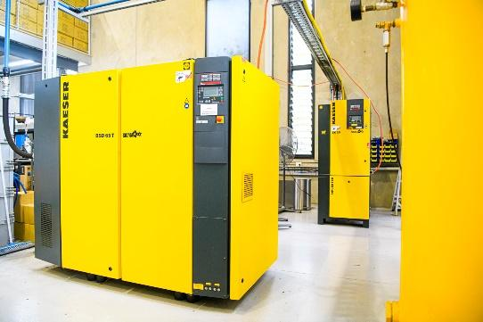
Caption: The Kaeser BSD 65 T selected to meet the additional compressed air requirements of the new direct injection moulding machine at Victor Footwear.

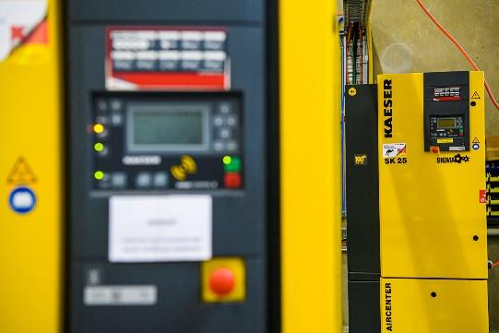 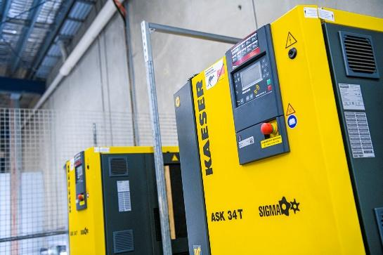
Caption: The Kaeser Aircenter SK25 and two Kaeser ASK 34 T’s also in operation at Victor Footwear to meet the facilities compressed air requirements.

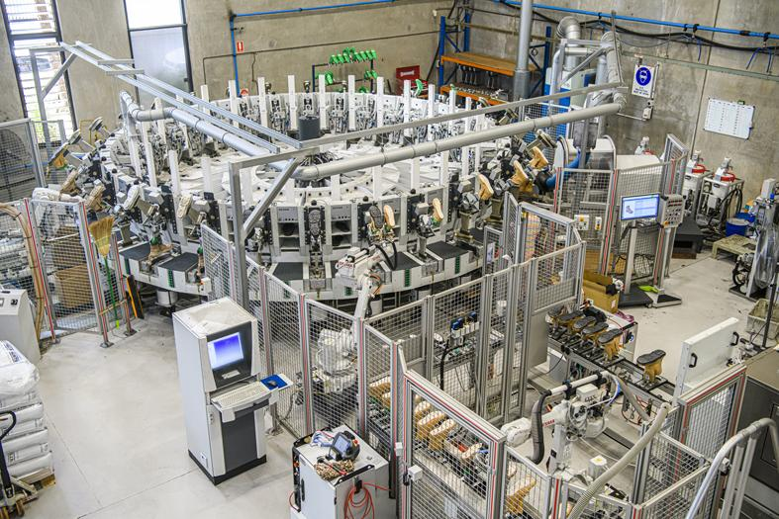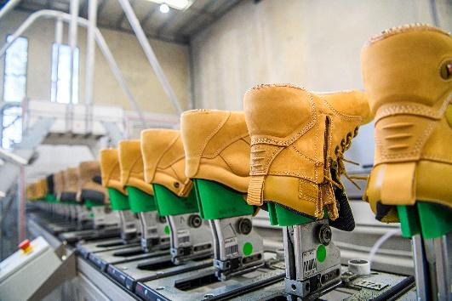
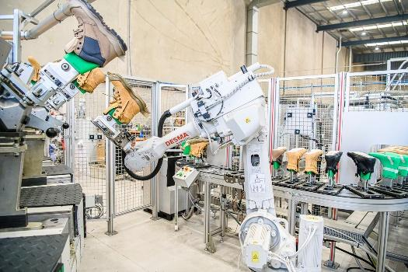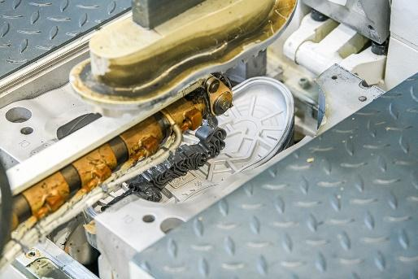
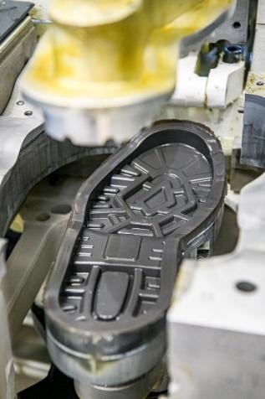 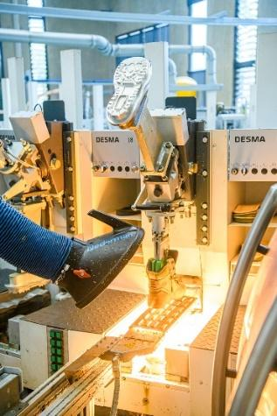
Caption: Representing the latest method of attaching soles to footwear uppers - here the advanced dual density soles of all Mongrel Boots are directly injected onto an upper.

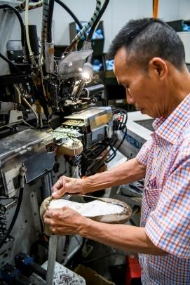 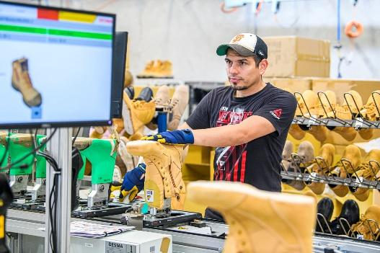
Caption: Compressed air is an essential utility required in many stages of the manufacturing process at Victor Footwear.

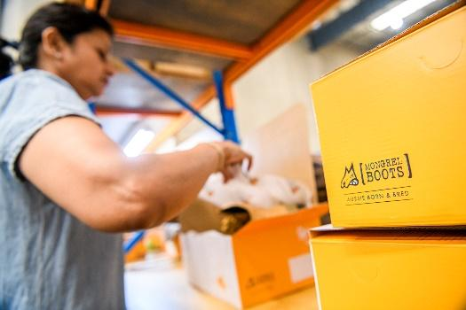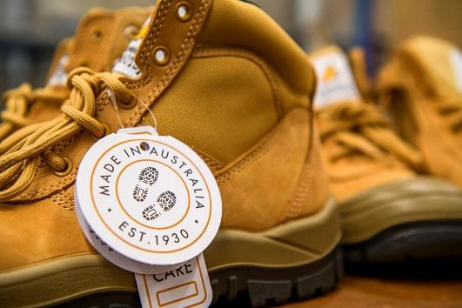
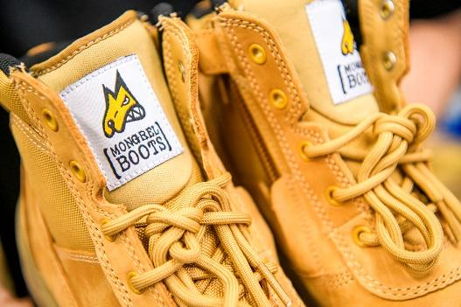
Caption: Victor Footwear is a fifth-generation family owned and operated Australian footwear manufacturer responsible for the truly ‘Aussie Born and Bred’ Mongrel Boots brand of safety and non-safety work boots.

Kaeser photo(s) – free for publication.

