The cooler way to cool air
ACAs – Perfect for temperature-sensitive blower applications
As you might expect from one of the world’s leading air system providers, Kaeser Compressors not only offers a comprehensive range of solutions for the blower sector, but also delivers that little bit more. The ACA series of blower after-coolers from Kaeser is one such example.
Heat is always produced as a result of compressing air – with rotary blowers the air discharge temperature can be as high 150 °C. However, there are many applications where excessive heat can be a disadvantage, such as pneumatic conveying of baking mixes or bulk materials containing fat, e.g. animal feed. Plastic granules are also often stable only up to 60 °C. And there are multiple applications of blowing air as a cooling medium.
With profund experience in air system design and planning, Kaeser Compressors was able to provide an exceptionally efficient and elegant engineering solution: air-cooled after-coolers (ACAs) specifically designed for use with rotary blowers. ACAs will reduce blowing air temperature from 150 °C to 10 °C above ambient without the complication and expense associated with water-cooled systems. Furthermore, they ensure maximum air usage with minimal pressure loss.

File: h-aca-l-nz
Approved for publication, copy acknowledgement appreciated
Image:

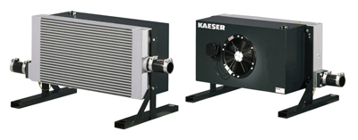
Kaeser Compressors’ ACA unique air cooled aftercoolers are simple to install and work very efficiently

