October 2018

Kaeser Compressors launches new website

Kaeser Compressors New Zealand launched its new website earlier this month. Along with a fresh appearance and a simplified navigation, the new website has been designed to be user- and mobile- friendly.

The new Kaeser website was created with the end-user in mind. A simplified navigation now divides the website into just four sections; products, solutions, services and company. In addition a responsive design ensures that whether a visitor is viewing the website from a PC, tablet or smart phone, the website will adapt to suit the device.

The upgraded product section features extensive product range information and now also includes quick access to technical specifications and in many cases 360-degree product views and videos. There are also a myriad of compressed air resources available to Kaeser website visitors including;

The Kaeser toolbox calculators (https://nz.kaeser.com/services/know-how/calculator/)
From a unit conversion calculator to calculating pressure drop, air receiver size and leakages - the Kaeser Toolbox includes a number of practical online calculators and is definitely a section worth bookmarking for repeat visits!

Whitepapers (https://nz.kaeser.com/services/news-and-dates/whitepapers/)
Kaeser regularly writes and presents in-depth reports on compressed air topics such as energy efficiency, as well as advisory articles to assist compressed air users in - for example - selecting the right compressed air equipment for their application. All current whitepapers can be easily accessed from the upgraded Kaeser website.

Compressed air engineering handbook (https://nz.kaeser.com/services/know-how/compressed-air-engineering-advisor/)
Visitors to the new website can also access the Compressed Air Engineering handbook. Following an in-depth introduction to the field of compressed air technology, this handbook covers a series of practical tips for system operators and compressed air users.

Kaeser invites users to visit www.kaeser.co.nz and experience its upgraded website for themselves!
-END-
From 2.2 to 500 kW, Kaeser Compressors manufactures a wide range of compressors and associated auxiliary equipment that meet the varying requirements of a diverse range of industries and applications.

One of the world’s largest manufacturers of rotary screw compressors, Kaeser Compressors is represented globally in over 100 countries through a dedicated network of branches, subsidiary companies and authorised partners.

Kaeser Compressors NZ Limited provides comprehensive air compressor and blower sales and service throughout New Zealand from its offices in Auckland, alongside a dedicated and nationwide network of authorised partners.

For editorial and advertising enquiries contact: Beth Wood, Marketing Manager
Press office: +61 3 9791 5999 Fax: +61 3 9791 5733
E-mail: beth.wood@kaeser.com

KAESER COMPRESSORS NZ Limited – 18B Tarndale Grove, Albany, Auckland 0632, New Zealand
Phone: +64 9 941 0499 – www.kaeser.co.nz – E-mail: info.newzealand@kaeser.com

File: O-website-launch-nz
Approved for publication, copy acknowledgement appreciated
Image:

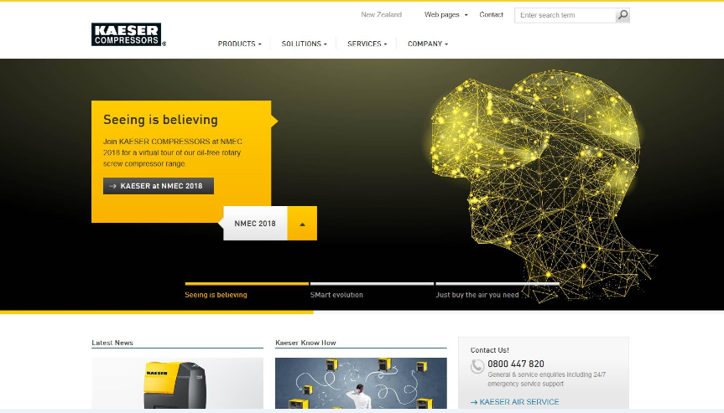
Caption: Kaeser Compressors NZ launches new website
014_Image 1_NZ website.JPG

((Kaeser photo – free for publication))

