July 2020

Aluminium joinery specialist reliably meets its upgrade requirements with an all-in-one solution from Kaeser

Bespoke aluminium joinery specialist Fisher West Auckland recently invested in an all-in-one Kaeser SXC series compressed air supply system to reliably meet the compressed air requirements of its New Lynn manufacturing facility.

Fisher West Auckland specialises in bespoke aluminium joinery projects. This includes the manufacture of the Fisher® Window and Doors product range - New Zealand’s oldest and most trusted brand of joinery.
From renovations to replacements to new builds - the Fisher® range of windows and doors can be found in properties across the nation. Crafted for New Zealand’s unique environment, the range includes awning, bifold, casement and sliding windows right through to sliding and hinged door solutions.

Making good products relies on good products
An ageing compressed air system recently led Ross Buckingham, Director at Fisher West Auckland, to contact Kaeser Compressors for a solution. From the cutting machinery through to the air clamps and hand tools - compressed air is an essential utility required within many stages of the joinery building process at Fisher West Auckland. Buckingham said; ‘We had heard really good things about the Kaeser product including how reliable they are. We rely on good products to make good products ourselves, so when it came time to replace our ageing compressed air system we wanted to talk to Kaeser.’
Kaeser recommended and subsequently installed an SXC 8 all-in-one compressed air supply system to reliably and efficiently meet Fisher West’s compressed air demand.

An all-in-one solution
The turnkey and compact SXC series from Kaeser Compressors is a complete compressed air supply system that incorporates a rotary screw compressor, refrigeration dryer and air receiver all within one space-saving compact package.

At the heart of each rotary screw compressor lies the Kaeser rotary screw compressor block featuring Sigma Profile rotors. These have been specially developed by Kaeser and require around 10 to 20 percent less energy than conventional rotors with the same air delivery capacity. This contributes significantly to the impressive overall efficiency of these systems.

The inclusion of an advanced Sigma Control 2 compressor controller further ensures reliable and efficient operation with maximum availability. With its efficient start-stop control, the Sigma Control 2 delivers optimised compressed air system performance at all times. Moreover, this advanced controller constantly monitors the entire SXC package.

With a maximum sound level of 69 dB(A), the SXC integrated packages are exceptionally quiet making them ideal at point of use. In addition, the SXC has been designed for maximum ease of maintenance. All maintenance and service points are easily accessible by simply lifting away the enclosure.

Now up and running, Buckingham concluded: ‘We have been really impressed with the Kaeser compressor - it’s reliable, it’s compact and it’s quiet in operation. Our health and safety system and moreover the safety of our staff is one of our top priorities. By shifting from a piston to a screw compressor, we have been able to reduce the noise considerably and make our work environment so much better to work in.
We’re also really happy with the programming features of the Kaeser compressor. We don’t have to worry about turning it on and off - it’s all set up to our requirements. And, the support and customer service from Kaeser from start to finish has been second to none.’

The compact all-in-one SXC series from Kaeser Compressors are available with drive powers of 2.2 to 5.5 kW, and produce flow rates from 0.26 to 0.80 m³/min, designed for pressures up to 15 bar. For more information visit nz.kaeser.com or phone 0800 447 820.
-END- Free for publication, copy appreciated
Editors Notes
From 0.18 to 515 kW, Kaeser Compressors manufactures a wide range of compressors and associated auxiliary equipment that meet the varying requirements of a diverse range of industries and applications.

One of the world’s largest manufacturers of rotary screw compressors, Kaeser Compressors is represented globally in over 100 countries through a dedicated network of branches, subsidiary companies and authorised partners.

Kaeser Compressors NZ Limited provides comprehensive air compressor and blower sales and service throughout New Zealand from its offices in Auckland, alongside a dedicated and nationwide network of authorised partners.

For editorial and advertising enquiries contact: Beth Wood, Marketing Manager
Press office: +61 3 9791 5999 Fax: +61 3 9791 5733
E-mail: beth.wood@kaeser.com

KAESER COMPRESSORS NZ Limited
18B Tarndale Grove, Albany, Auckland 0632, New Zealand
Phone: +64 9 941 0499 Email: info.newzealand@kaeser.com
nz.kaeser.com
Kaeser photo(s) – free for publication, credits appreciated.

File: Q-Fisher-West-Case-Study-nz
Approved for publication, copy acknowledgement appreciated
Images: Contact our press office to request high res versions of the images found below
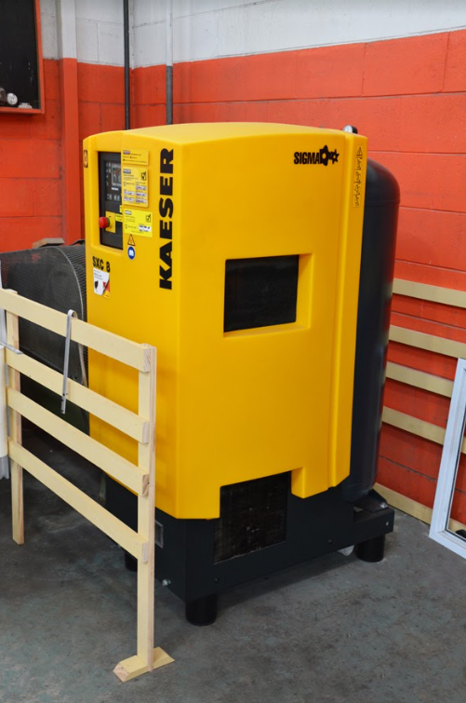
Caption: The Kaeser.SXC 8 all-in-one compressed air supply system at Fisher West Auckland.

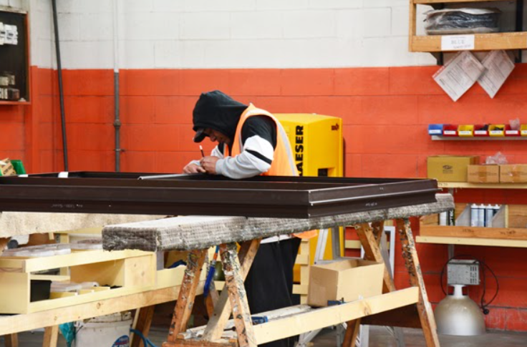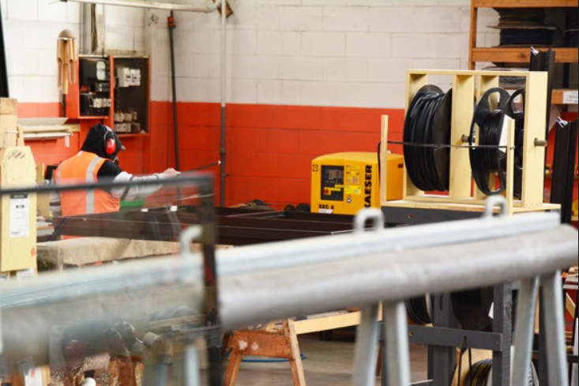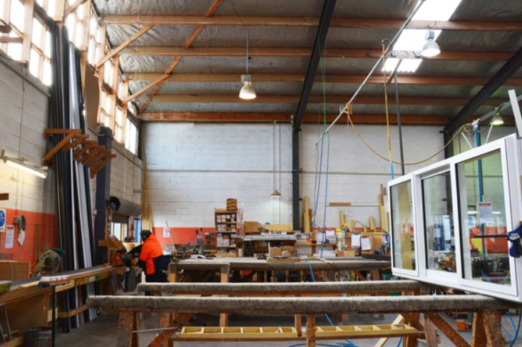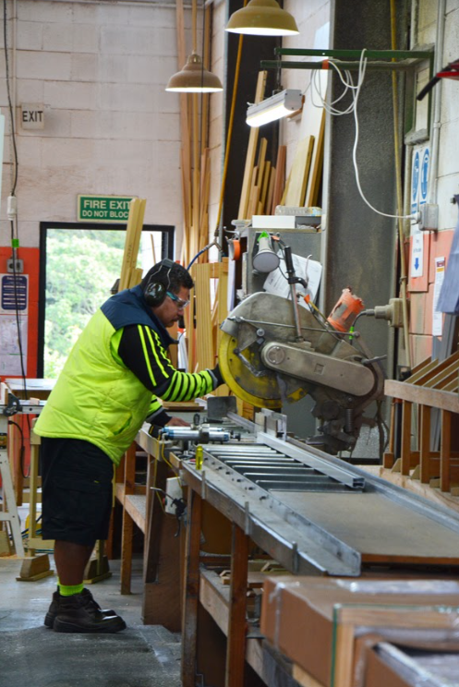
Caption: From the cutting machinery through to the air clamps and hand tools - compressed air is an essential utility required within many stages of the joinery building process at Fisher West Auckland.

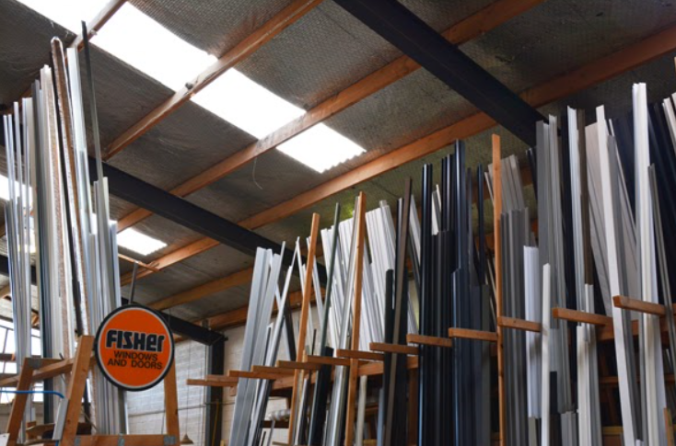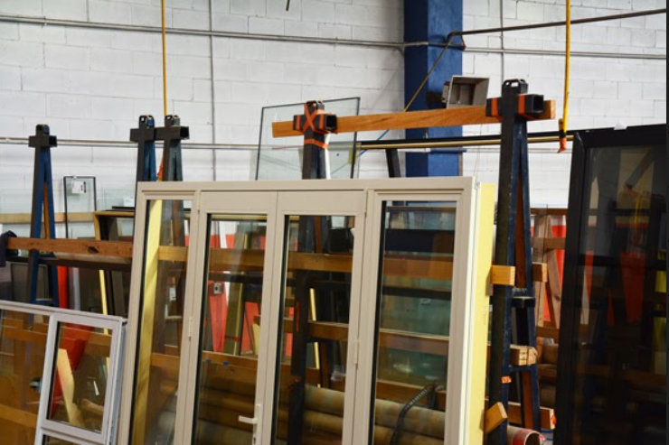
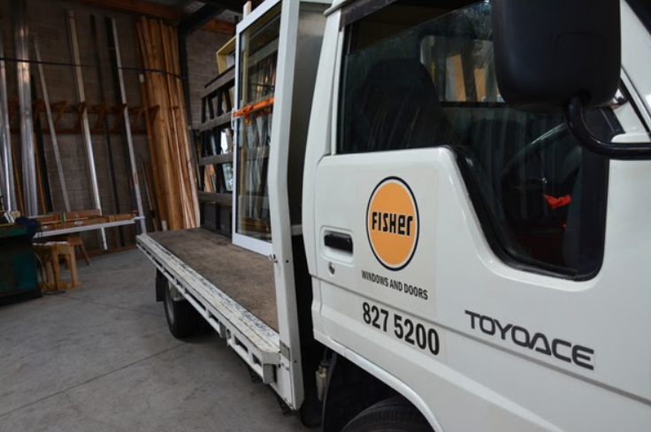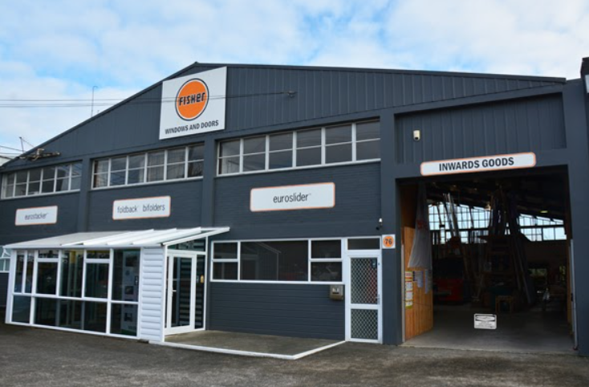
Caption: Crafted for New Zealand’s unique environment, the Fisher® range of windows and doors includes awning, bifold, casement and sliding windows right through to sliding and hinged door solutions.

Kaeser photo(s) – free for publication.

