January 2019

Achieving maximum energy savings with Kaeser’s next generation CSD(X) series

Kaeser Compressors has launched its next generation CSD(X) series of variable speed rotary screw compressors which are paving the way for the highest current efficiency gain, and thus reduced energy costs, when using variable-speed compressors.

As a leading compressed air systems provider and a renowned industry trendsetter, the family-owned company proudly presented yet another technological milestone some time ago: the introduction of synchronous reluctance motors for its SFC variable-speed screw compressors. After the ASD series, the CSD and CSDX series are the next to be equipped with this technology. This means significantly lower energy costs for end users, particularly in the crucial partial-load range, compared to the previous solution with asynchronous motors.

With the Sigma Profile and innovative drive concepts, Kaeser's rotary screw compressors already deliver outstanding performance and reliability. Combined with energy efficiency and space-saving design they deliver more compressed air and more energy savings. The roll-out of synchronous reluctance technology was the next step towards even greater efficiency.

The major advantage of this complete solution, which was developed in partnership with Siemens, is an efficiency gain of approximately ten percent in the partial-load range. Thanks to the innovative motors and the top IES2 classification as per the new EN 50598 efficiency standard, this solution offers unprecedented efficiency. For example, in the case of a CSD SFC series screw compressor, this translates into average energy cost savings of around $1,250 per year, based on approximately 6,000 operating hours at a rate of 10 cents per kilowatt hour. End users therefore not only enjoy maximum flexibility for specific applications and varying environmental conditions, but also with regard to load response.

Variable-speed drive with high system efficiency
Where a compressed air system includes a number of compressors, continuously running compressors with IE4 motors cover base load demand, whilst additional peak-load compressors respond flexibly to meet extra demand. To ensure maximum efficiency the system is controlled by a Sigma Air Manager 4.0. With the Siemens synchronous reluctance drive systems, this will be performed with even greater efficiency in the all-important partial load range.

This development has come about in response to the fact that the new EN 50598 eco-design standard applies not only to the efficiency values of individual drives, but represents a shift in regulatory emphasis to overall system efficiency and therefore assesses the compliance of variable-speed drive solutions, based on their overall system efficiency. With its variable-speed version (SFC) of the ASD to CSDX series, Kaeser paves the way for end users to embark on a path of minimal energy consumption and minimal operating costs.

The best of both worlds: synchronous and asynchronous motor technology
This new and innovative series of general-purpose motors combines the strengths of both asynchronous and synchronous motors in a single drive system. No aluminium, copper or expensive rare earth magnets are used in the rotors. Instead they are made of electrical steel with a specialised profile and arranged in series, making the drive highly durable and maintenance friendly, the characteristic advantages of asynchronous motors.
On the other hand, the control properties of the new motors are comparable to those of synchronous motors. The special rotor design enables reluctance motors to deliver high speeds without additional rotor warming due to current flow. The key to this lies in optimised matching of the drive system elements, i.e. the motor and frequency converter. It is the perfectly harmonised interplay between these two components that facilitates maximum energy savings.

The CSD(X) series of rotary screw compressors with SFC variable speed drives from Kaeser are available with drive powers of 45 to 90 kW, and produce flow rates from 2.13 to 16.03 m³/min, designed for pressures 7.5 to 13 bar. Visit www.kaeser.co.nz or phone 0800 447 820 for more information.
-END-
Editors Notes
From 2.2 to 500 kW, Kaeser Compressors manufactures a wide range of compressors and associated auxiliary equipment that meet the varying requirements of a diverse range of industries and applications.

One of the world’s largest manufacturers of rotary screw compressors, Kaeser Compressors is represented globally in over 100 countries through a dedicated network of branches, subsidiary companies and authorised partners.

Kaeser Compressors NZ Limited provides comprehensive air compressor and blower sales and service throughout New Zealand from its offices in Auckland, alongside a dedicated and nationwide network of authorised partners.

For editorial and advertising enquiries contact: Beth Wood, Marketing Manager
Press office: +61 3 9791 5999 Fax: +61 3 9791 5733
E-mail: beth.wood@kaeser.com

KAESER COMPRESSORS NZ Limited – 18B Tarndale Grove, Albany, Auckland 0632, New Zealand
Phone: +64 9 941 0499 – www.kaeser.co.nz – E-mail: info.newzealand@kaeser.com

File: A-CSD-X-2019-nz
Approved for publication, copy acknowledgement appreciated

Image:

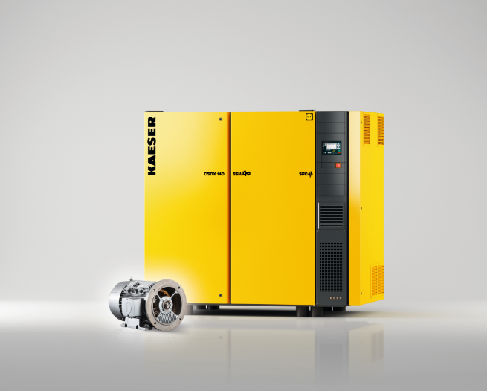
003_Image 1_KAESER CSD CSDX series.jpg
Caption: The variable-speed versions of Kaeser’s CSD/CSDX series rotary screw compressors feature a synchronous reluctance drive system from Siemens.

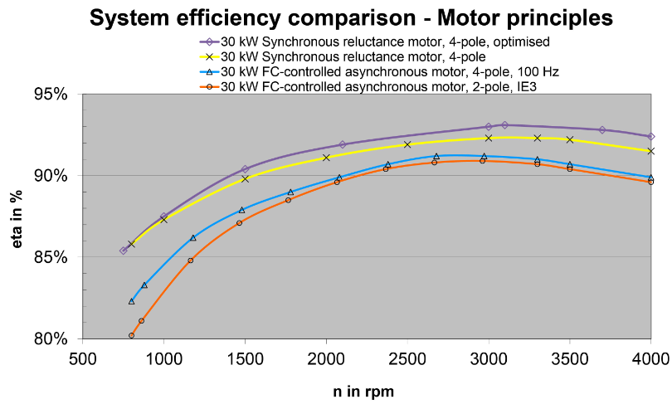
003_Image 2_System efficiency comparison.jpg
Caption: The synchronous reluctance motor boasts significantly enhanced efficiency rates. The variable-speed versions of Kaeser’s CSD/CSDX series rotary screw compressors feature a synchronous reluctance drive system from Siemens.

((Kaeser photo – free for publication))

