New refrigeration desiccant dryer Hybritec for large air volumes
More compact and efficient than ever before
Kaeser Kompressoren's new compact Hybritec dryers safely and reliably dry large volumes of compressed air to a pressure dew point of minus 40° C, do it efficiently and cut power costs while taking up relatively little space.
When pressure dew points as low as minus 40° C are specified, Kaeser Kompressoren's new compact dryers combining refrigeration and desiccant drying technology in a single unit achieve this reliably and efficiently, even for high air volumes. Kaeser has extended the range of its Hybritec design, which had already been available for volumes of up to 20 m³, to cover capacities up to 67 m³/min. The new DTI to DTH series Hybritec dryers use up to 50% less energy than conventional desiccant dryers. The secret lies in the synergy of the two drying processes.
By cleverly arranging the internal components, Kaeser was able to significantly improve serviceability and reduce the footprint by up to 49% without compromising performance. The space savings are unprecedented. All parts requiring maintenance are accessible from the front, which not only reduces the time and effort required for servicing, but also helps cut costs even further.
Of course the newly enhanced compact Hybritec combination dryers retain the familiar advantages of the previous Hybritec series, such as consuming 50% less power than a separately driven heat regenerated desiccant dryer (for minus 40° C dew point without refrigeration pre-dryer), very low processing temperatures and long drying cycles. The resulting significantly lower mechanical and thermal stress on the components extends their service life and contributes to dramatically lower lifecycle costs.
When it comes to compressed air quality, the combination dryers' pressure dew points are significantly more stable at low compressed air discharge temperatures due to the very low processing temperatures and long cooling cycles. The Eco Control user interface with its intuitive touch panel makes operation simple and safe. The new Hybritec combination dryers are the right choice wherever stable and reliable pressure dew points as low as minus 40° C are required, where energy efficiency is important and where space is limited.

File: d-hybritec-kombitrockner-anz
Approved for publication, copy acknowledgement appreciated
Image:

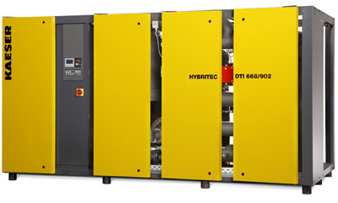
The new Hybritec combination dryers from Kaeser Compressors cater to free air deliveries up to 67 m³/min. They combine energy efficiency, a compact footprint and reliable, stable generation of pressure dew points to minus 40° Celsius.

