September 2021

Producing extremely dry compressed air:
A compact, efficient and dependable solution

Reliable and efficient compressed air treatment is essential in meeting the stringent air quality standards required in the manufacture of food and beverages. Kaeser Compressors discusses how its latest range of dry-running rotary screw compressors featuring the patented i.HOC rotating dryer - not only provide a dependable source of quality compressed air with pressure dew points as low as -30ºC - but does so energy efficiently and all from within a space saving design.
There are some demanding applications in the food and beverage industry that require extremely dry compressed air. Generally speaking, the drier the air needs to be, the lower the pressure dew point required and, the lower the pressure dew point, the higher the level of complexity, space requirement and cost involved. But, for those applications needing to attain extremely dry compressed air to a negative pressure dewpoint of around -30ºC, Kaeser Compressors presents an integrated and intelligent solution that is energy efficient and space saving.

Integrated Heat of compression (iHOC) dryers
Where extremely dry and clean compressed air is required, Kaeser’s dry-running rotary screw compressors featuring an “integrated Heat Of Compression dryer” (i.HOC dryer) may be just the solution.

Here, the dryer is integrated within the dry-running compressor. In this dryer design the desiccant is contained in a drum through which the compressed air flows in an axial direction. Desiccant regeneration and compressed air drying take place continuously, within a single pressure receiver. The drying and regeneration sectors are separated, however, both structurally and in terms of process. Slight pressurisation of the drying sector ensures that once dried, the compressed air does not reabsorb moisture from the regeneration air flowing by, in the adjacent sector.

Drying without additional energy consumption
In i.HOC dryers, desiccant regeneration takes place continuously, using the heat that already exists in the hot compressed air. Following the final air compression stage in the compressor, the hot compressed air is not sent to the compressors second stage coolers and lost, but it is diverted directly to the drying sector of the integrated rotating dryer before it exits the compressor. The heat arising as a result of compression of the air is therefore also used for desiccant regeneration. This heat is freely available without cost, as no additional energy is required for the drying process. This translates into maximum efficiency and outstanding drying reliability.
The perfect interplay between the compressor and dryer also avoids additional energy costs, which are unavoidably incurred in the case of conventional desiccant dryers which use additional, external energy for desiccant regeneration.

Reliable pressure dew point
Modern i.HOC units also guarantee reliable and stable maintenance of low pressure dew points to -20ºC, and under special conditions even to -40ºC.
In integrated rotation dryers, the attainable pressure dew point is determined by the compressed air inlet temperature in the drying sector and the available regeneration potential, which depends on the mass flow of regeneration air and its temperature. The i.HOC dryer therefore uses the entire mass flow of hot compressed air available at the end of the second compression stage for regeneration purposes. This is why it is referred to as a “full stream” rotation dryer.
The higher regeneration potential of full-stream rotation dryers is especially advantageous when it comes to high cooling medium temperatures at the regeneration air cooler, low compression ratios in the compressor and – in partial-load operation – more consistent and significantly lower pressure dew points.

Intelligent regeneration management
The attainable pressure dew point will fluctuate with the temperature of the ambient air (insofar as it acts as a cooling medium) – and this effect is especially pronounced in air-cooled compressors with integrated rotation dryers. For instance, if temperatures temporarily peak around 40 °C in the inlet area during summer months, it may be necessary to enhance the rotation dryer’s regeneration potential during this time, to avoid exceeding a required pressure dew point of -20°C.
Here the discharge temperature of the i.HOC full-stream rotation dryer following the second stage (i.e. the regeneration air temperature) can be increased by a controlled bypass around the first compression stage cooler. The regeneration air temperature (and consequently, the regeneration potential) increases to ensure maintenance of the target pressure dew point. Using the bypass to increase the regeneration air temperature to meet process requirements makes sense – especially as the conventional technology available on the market for electrically heating the regeneration air consumes significantly more energy.

Conclusion
When it comes to meeting stringent air quality standards, reliably and energy efficiently, a dry-running compressor with an integrated rotation dryer is an excellent choice for users with a certain usage profile: demanding requirements in terms of compressed air quality and pressure dew point consistency; relatively little installation space; and challenging environmental conditions. For more information visit nz.kaeser.com or phone 0800 447 820.
-END- Free for publication, copy appreciated
Editors Notes
From 0.18 to 515 kW, Kaeser Compressors manufactures a wide range of compressors and associated auxiliary equipment that meet the varying requirements of a diverse range of industries and applications.
One of the world’s largest manufacturers of compressors, blowers and compressed air systems, Kaeser Compressors is represented throughout the world by a comprehensive network of branches, subsidiaries and authorised distribution partners in over 140 countries.

Kaeser Compressors NZ Limited provides comprehensive air compressor and blower sales and service throughout New Zealand from its offices in Auckland, alongside a dedicated and nationwide network of authorised partners.

For editorial and advertising enquiries contact: Beth Wood, Marketing Manager
Press office: +61 3 9791 5999 Fax: +61 3 9791 5733
E-mail: beth.wood@kaeser.com

KAESER COMPRESSORS NZ Limited
18B Tarndale Grove, Albany, Auckland 0632, New Zealand
Phone: +64 9 941 0499 Email: info.newzealand@kaeser.com
nz.kaeser.com
File: N-iHOC-nz
Approved for publication, copy acknowledgement appreciated
Image:

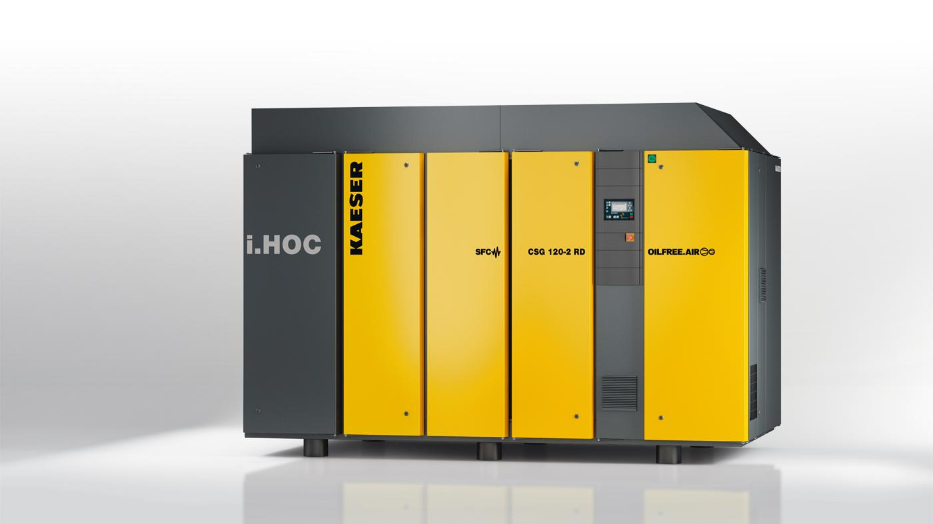
Caption: A Kaeser dry-running rotary screw compressor featuring the patented i.HOC rotating dryer.
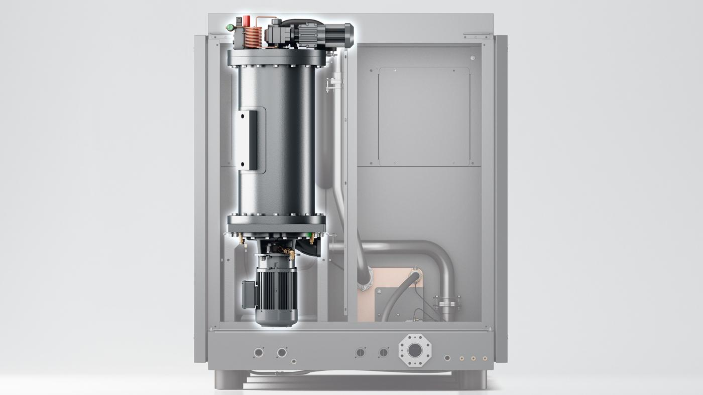
Caption: The i.HOC dryer is integrated into Kaeser’s dry-running rotary screw compressor.

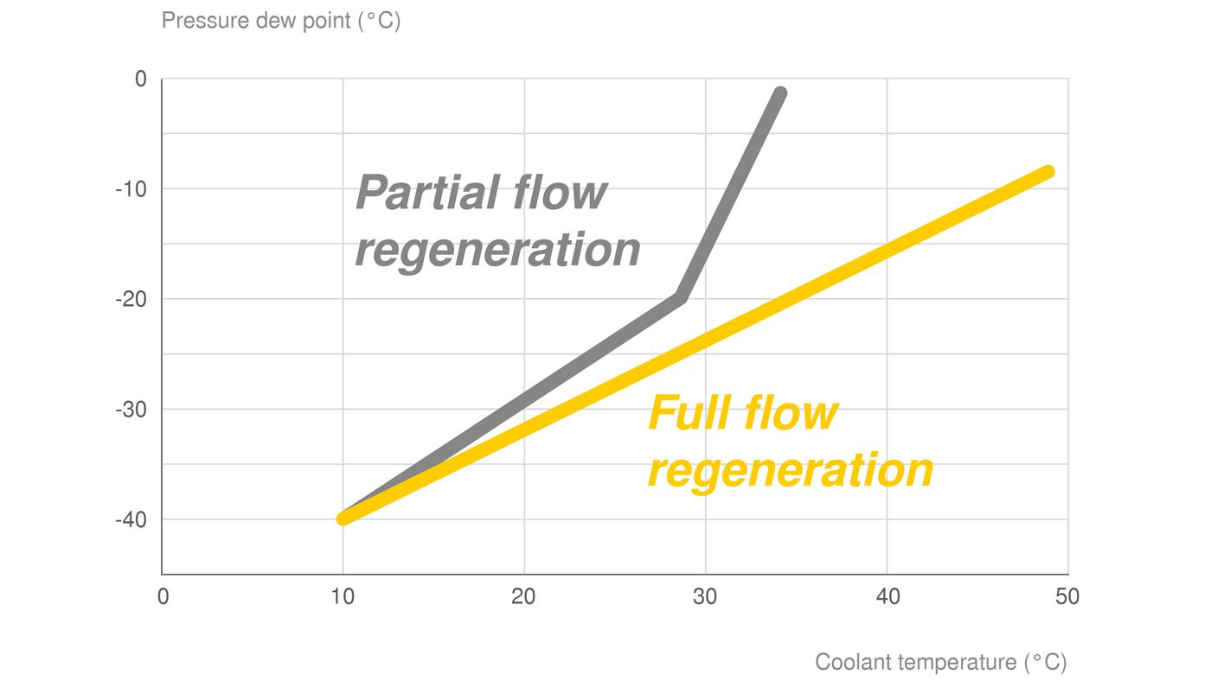
Caption: Thanks to full-stream regeneration technology, the i.HOC rotation dryer is capable of exploiting much more heat than conventional dryers - an efficient feature that translates into lower energy costs.
Kaeser photo(s) – free for publication, credits appreciated.

