October 2021

Kaeser announced as sponsor of MESNZ Lunch and Learn Webinar series

Kaeser Compressors New Zealand has just announced that it is the new sponsor of the Maintenance Engineering Society of New Zealand (MESNZ) Lunch and Learn Webinar Series.
MESNZ aims to be at the forefront of helping develop engineers through facilitating professional development and collaboration across all levels of the industry. The Society provides the forum to give young apprentices the best opportunity to learn and grow along with the means for the wise old heads in the industry to give back and give a hand up to the next generation. The best part is occasionally the wise old heads can also learn a thing or two along the way.

Responding to the changing environment that COVID-19 created, in 2020 MESNZ introduced a series of Lunch and Learn Webinars in place of the usual in-person conference and network evening events. This brought together members and interested parties for one hour webinars held at a lunchtime, with industry speakers providing insights on a range of topics. Having proved to be very popular, the MESNZ Lunch and Learn Webinar series became a more permanent fixture on the MESNZ events calendar earlier this year.

As a volunteer-run non-profit organisation passionate about advancing the productivity of New Zealand’s manufacturing plants (cost savings, up-time, reliability, availability, efficiency, etc) MESNZ welcomes the support of Kaeser Compressors, a long standing supporter of the Society. Kaeser Compressors’ support has enabled the MESNZ Lunch and Learn Webinar series to be expanded to a weekly offering at no cost to participants at a time when industry everywhere is under pressure to operate both safely and efficiently.

There are a number of Kaeser Compressors MESNZ Lunch and Learn Webinar series events already planned. For details of the upcoming events visit nz.kaeser.com or www.mesnz.org.nz
-END- Free for publication, copy appreciated
Editors Notes
From 0.18 to 515 kW, Kaeser Compressors manufactures a wide range of compressors and associated auxiliary equipment that meet the varying requirements of a diverse range of industries and applications.
One of the world’s largest manufacturers of compressors, blowers and compressed air systems, Kaeser Compressors is represented throughout the world by a comprehensive network of branches, subsidiaries and authorised distribution partners in over 140 countries.

Kaeser Compressors NZ Limited provides comprehensive air compressor and blower sales and service throughout New Zealand from its offices in Auckland, alongside a dedicated and nationwide network of authorised partners.

For editorial and advertising enquiries contact: Beth Wood, Marketing Manager
Press office: +61 3 9791 5999 Fax: +61 3 9791 5733
E-mail: beth.wood@kaeser.com

KAESER COMPRESSORS NZ Limited
18B Tarndale Grove, Albany, Auckland 0632, New Zealand
Phone: +64 9 941 0499 Email: info.newzealand@kaeser.com
nz.kaeser.com
File: P-MESNZ-lunch-learn-nz
Approved for publication, copy acknowledgement appreciated
Image:
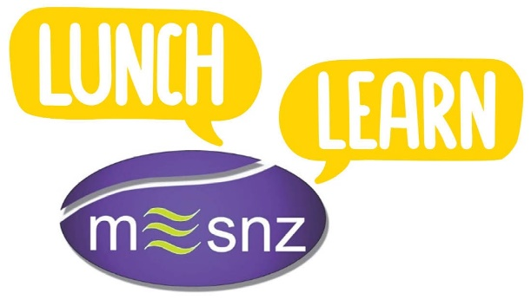
Caption: Kaeser Compressors announced as sponsor of the MESNZ Lunch and Learn Webinar series

Kaeser photo(s) – free for publication, credits appreciated.

