January 2020

Kaeser expands its blower range with PillAerator acquisition

Kaeser Compressors recently expanded its range of blowers with the acquisition of PillAerator GmBH. The inclusion of this range of turbo blowers significantly expands Kaeser’s offering to the water and wastewater industry sectors.

With the recent acquisition of PillAerator GmBH, Kaeser has added turbo blowers to its range of rotary lobe and rotary screw blowers. This action significantly expands Kaeser’s offering for the water and wastewater industry sectors, as well as other large flow, low pressure applications including bioreactors and flue gas desulphurisation.

‘The PillAerator acquisition was an excellent fit due to both companies’ high standards for product quality, innovative design, and energy efficiency,” said Peter Eckberg, Managing Director at Kaeser Compressors NZ. ‘PillAerator’s simple and reliable design has a proven record for performance with units operating around the world, and we are already getting a lot of interest from our New Zealand wastewater partners.’

Available with flows from 133 up to 283 m³/min, PillAerator blowers feature gas-tight, permanent magnet motors with active magnetic bearings, integrated frequency converters and closed-loop water cooling. Units are compact and quiet plus advanced controls offer full interoperability with SCADA systems.

For more information visit nz.kaeser.com or phone 0800 447 820.
-END-
Editors Notes
From 2.2 to 500 kW, Kaeser Compressors manufactures a wide range of compressors and associated auxiliary equipment that meet the varying requirements of a diverse range of industries and applications.

One of the world’s largest manufacturers of rotary screw compressors, Kaeser Compressors is represented globally in over 100 countries through a dedicated network of branches, subsidiary companies and authorised partners.

Kaeser Compressors NZ Limited provides comprehensive air compressor and blower sales and service throughout New Zealand from its offices in Auckland, alongside a dedicated and nationwide network of authorised partners.

For editorial and advertising enquiries contact: Beth Wood, Marketing Manager
Press office: +61 3 9791 5999 Fax: +61 3 9791 5733
E-mail: beth.wood@kaeser.com

KAESER COMPRESSORS NZ Limited – 18B Tarndale Grove, Albany, Auckland 0632, New Zealand
Phone: +64 9 941 0499 – https://nz.kaeser.com – E-mail: info.newzealand@kaeser.com

File: H-PillAerator-NZ
Approved for publication, copy acknowledgement appreciated
Images:

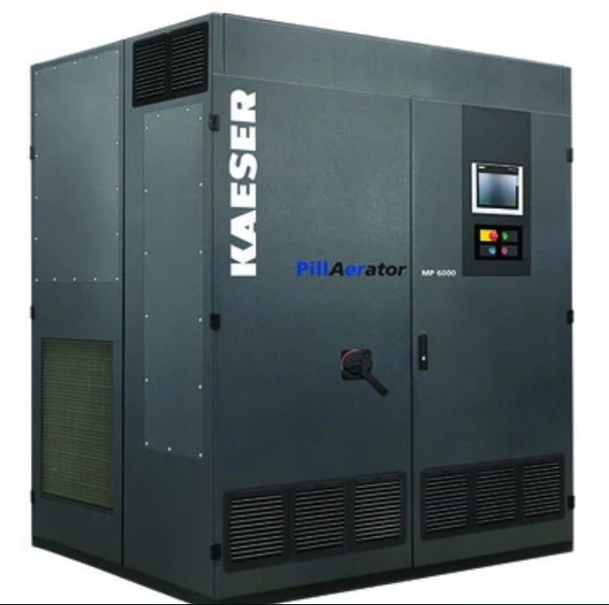
Caption: Kaeser introduces turbo blowers for wastewater treatment and other low pressure applications

((Kaeser photo – free for publication))

