Kaeser assists Wilson Transformer Company in optimising the energy efficiency of its compressed air systems
Kaeser Compressors Australia has assisted Wilson Transformer Company in meeting the increased demand for compressed air that its new state-of-the-art facility has created, whilst optimising the energy efficiency of its compressed air systems with the installation of 6 CSD series rotary screw compressors.
Wilson Transformer Company (WTC) is a leading Australian manufacturer of power and distribution transformers. At the four-hectare head office in Glen Waverley, Victoria the Power Business Unit design, engineer, manufacture and test a range of quality power transformers including generator, substation and auto transformers up to 550 MVA 400 kV.
Manufacturing in Victoria since 1933, WTC has grown steadily to become the largest Australian manufacturer of power and distribution transformers by investing in people, technology and assets. As such, over the past five years, the Company has committed major resources into the development of its power and distribution transformer capability. This has involved a major expansion of its Glen Waverley facility which included upgrading the compressed air system. As Alan Veitch Improvement Manager for the Power Business Unit at WTC explains:
'In planning the expansion of our production facility it became apparent that our existing compressor station was not going to be able to meet the new compressed air demand. The ageing compressed air system was also becoming increasingly inefficient and so costly to operate. The expansion therefore presented us with the ideal opportunity to address this issue at the same time.'
The plant at Glen Waverley incorporates two main workshop areas; one for the electrical operations of core cutting, insulation preparation, coil winding, transformer assembly, processing and testing; and the other to handle the mechanical operations which include fabrication, welding, grit blasting and painting.
Compressed air is used to power a number of operations across the two workshop areas from; breathing air used in the blasting facility to general purpose pneumatic control systems on for example the drying ovens and oiling systems.
The biggest requirement for compressed air in planning the upgrade however, was the introduction of air skates. Powered by compressed air, air skates can lift and move heavy-loads on a cushion of air. As Veitch explains:
'We wanted to introduce air skates into the facility in order to lift and manoeuvre the largest transformers into restricted access areas such as the testing bays where the cranes cannot go.'
To meet the increased compressed air demand and ensure optimum energy efficiency, WTC chose to invest in six Kaeser rotary screw compressors; four CSD T models with integrated refrigeration dryers and two CSD(X) T SFC variable speed drive models.
The CSD(X) T series from Kaeser deliver premium quality compressed air and superior efficiency. At the heart of every CSD(X) T rotary screw compressor lies a low-speed Sigma Profile airend equipped with flow optimised rotors. Developed by Kaeser, the Sigma profile achieves power savings of up to 15 percent compared with conventional screw airend rotor profiles for a highly energy efficient solution. In addition, all Kaeser rotary screw airends are powered by premium efficiency IE3 drive motors for maximum performance and reliability.
Combining a rotary screw compressor with a compact integrated refrigeration dryer makes the CSD(X) T units ideal where the user requires an all-in-one solution. The integrated refrigeration dryers in these units also provide further energy savings, with a sophisticated control on these dryers ensuring that they are only active when compressed air actually needs to be dried. This achieves the required compressed air quality with maximum efficiency.
And, where compressed air demand fluctuates the CSD(X) T SFC series really comes into its own. Utilising a variable speed drive, these units have been designed to vary the speed of the airend to directly match the FAD (flow) required by the end user. This saves energy, maximises service life and enhances reliability.
Veitch concluded: 'We primarily chose these compressors because Kaeser is well known for manufacturing high quality, reliable and efficient compressor solutions. And, one of the reasons we were aware of this is because Kaeser was one of our customers and we had in fact supplied them with a Wilson Transformer some years earlier!
The main compressor system is now effortlessly powering the new air skates which together can lift and manoeuvre some 300 tonnes of weight.
All of the Kaeser compressors have proven to be efficient and reliable in operation, and we are particularly impressed with their ease of maintenance. It is also evident to us that upgrading the compressed air equipment is saving us energy.'
Since the installation of the compressors, WTC has continued to rely upon Seaford, Victoria based Kaeser Partner - Air Maintenance Pty Ltd - for its on-going compressor maintenance requirements with whom the company has a long standing relationship.
The CSD series of rotary screw compressors from Kaeser are available with drive powers up to 90 kW producing free air deliveries from 1.07 up to 16.16 m³/min.

File: Q-WTC-nz
Approved for publication, copy acknowledgement appreciated
Images: (contact the press office for high res copies of the following images)

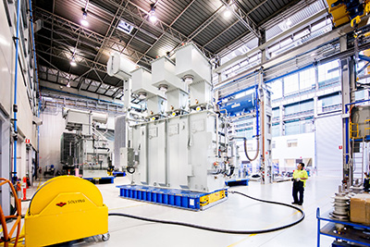
Caption: Powered by the Kaeser compressors, the air skates at WTC can lift up to 300 tonnes of weight and are responsible for moving the transformers into the testing bay.

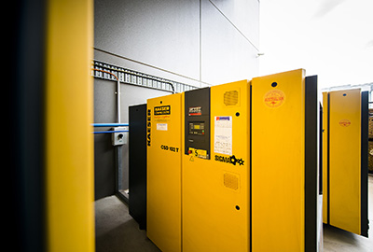
Caption: As part of the development of its power and distribution transformer capability WTC chose to invest in six Kaeser CSD series rotary screw compressors.

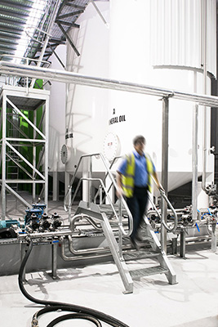
Caption: Compressed air is used to power a number of operations at WTC including powering the pneumatic controls on the oiling system.

