April 2024

Reliable. Intelligent. Energy Saving:

Kaeser launches its next generation i.DC series desiccant dryers

Kaeser Compressors NZ has just announced the launch of its latest generation of heatless regenerative desiccant dryers which can lower the pressure dew point of the compressed air to -70ºC. Ideal for sensitive applications such as those found in the food and beverage industry, the intelligent new i.DC series delivers a reliable supply of extremely dry compressed air. Considerable energy savings can be realised with these new models, thanks to the inclusion of the new Eco Control 3 controller - featuring an innovative, trend-detecting pressure dew point control.

With flow rates from 1.60 to 155.5 m³/min, the latest generation of Kaeser’s i.DC series heatless regeneration desiccant dryers, can lower the pressure dew point (PDP) of the compressed air to -70ºC. This presents the ideal solution for sensitive applications that require extremely dry air, such as those found in the food and beverage, pharmaceuticals and electronics industries. At the same time the i.DC series desiccant dryers deliver dependable frost protection for control valves and lines.

Reliable, advanced and compact

Within a rugged and compact design lies premium quality materials and components, which ensure the i.DC series of desiccant dryers from Kaeser deliver maximum compressed air availability and reliability. This includes the use of long-lasting desiccant which ensures

outstanding pressure stability and resistance to liquid water. This keeps pressure dew points reliably low, even under demanding operating conditions.

Intelligent and energy saving control

The centre piece of the optimised i.DC series heatless regenerative desiccant dryers from Kaeser Compressors is the new Eco Control 3 controller, which saves considerable energy by automatically reacting to variations in compressed air requirement, ambient temperatures and network pressure, by adjusting the dryer’s regeneration cycle to the prevailing conditions.
Cost-effective, maintenance-free and extremely robust, the innovative trend-detecting pressure dew point control operating mode, detects and analyses temperature changes in the desiccant bed, to determine the desiccant loading condition. If the desiccant in one chamber is fully loaded, a switch is made to the regenerated chamber. This method is more cost-effective and secure than conventional dew point controllers since it reacts to changes in the desiccant temperature differential instead of responding only when the pressure dew point at the dryer outlet increases.

The Eco Control 3 controller saves considerable energy - especially with variable flow rates, pressures or temperatures. It also offers comprehensive system monitoring and reporting, as well as a Modbus TCP interface connection to the Kaeser Sigma Network.

Low life-cycle costs

The new i.DC series of desiccant dryers from Kaeser achieve extremely low life-cycle costs. The costs for regeneration and maintenance materials are significantly lower than for conventional models using a molecular sieve filling. For a 10 m³/min i.DC series desiccant dryer, this can mean potential savings up of to $160,000 NZD over a 10-year period. In addition, the i.DC dryers require far less maintenance than conventional models on the market.

Meeting the highest air quality standards

The i.DC series of desiccant dryers from Kaeser can be optionally coupled to an ACT activated carbon adsorber, enabling the production of oil-free compressed air that meets the highest quality standards (ISO 8573-1 Class 1 residual oil content).

Flow rates from 1.60 to 155.5 m³/min, pressure from 5 to 16 bar. For more information visit nz.kaeser.com or phone 0800 447 820.
-END-

Editors Notes
Kaeser Compressors is one of the world’s leading compressor manufacturers and compressed air system providers, represented internationally by a comprehensive network of subsidiaries and authorised distribution partners in over 140 countries.

Kaeser’s comprehensive product range comprises; reciprocating and rotary screw compressors ranging from 0.18 to 515 kW, portable rotary screw compressors, high-pressure and dry-running compressors, compressor control systems, vacuum pumps, rotary blowers, rotary screw blowers, turbo blowers, air filters, refrigeration & desiccant dryers, as well as compressed air system accessories and services.

Established in 2015, Kaeser Compressors NZ Limited, provides comprehensive sales and service throughout New Zealand, from its facility in Auckland, alongside an extensive network of authorised partners.

For editorial and advertising enquiries contact:
Press office: +64 9 941 0499 E-mail: marketing.nz@kaeser.com

KAESER COMPRESSORS NZ Limited

18B Tarndale Grove, Albany, Auckland 0632, New Zealand
Phone: +64 9 941 0499 Email: info.newzealand@kaeser.com Web: nz.kaeser.com

Images:
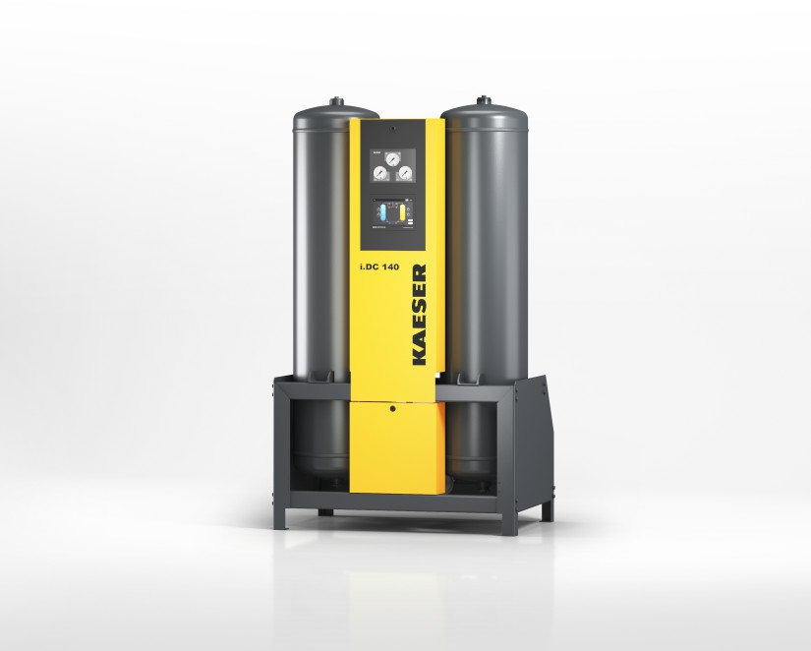
001_Image 1_KAESER iDC dryer.png

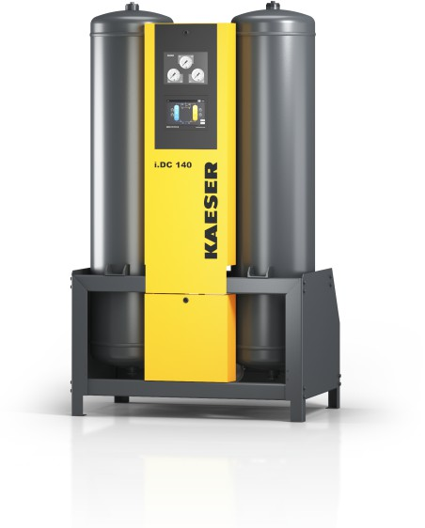
001_Image 2_KAESER iDC dryer.png
Caption: Reliable. Intelligent. Energy Saving: Kaeser launches its next generation i.DC series desiccant dryers

((Kaeser photo – free for publication))

