June 2024

Kaeser CBS series rotary screw blowers:

Powerful performance and impressive efficiency all in a compact solution

Up to 35 percent more efficient when compared to conventional rotary blowers, the CBS series from Kaeser brings all the advantages of rotary screw blower technology to lower flow rate applications, such as those found in wastewater treatment plants, and all in a compact solution.

For municipal or industrial wastewater treatment plants requiring compressed air with differential pressures of up to 1100 mbar, the CBS series rotary screw blower from Kaeser is the perfect solution – with motor powers from 7.5 to 22 kW and flow rates from 2.3 to 12.2 m³/min.
Thanks to its many advantages, the CBS also shines in applications such as the production of aeration air in water treatment processes including bioreactors, flotation and fluidisation. It’s up to 35 percent more efficient compared to conventional rotary blowers and offers significant energy advantages in the two-digit range compared to other screw and turbo blowers on the market. Thanks to its broad flow rate control range, the CBS can also cover extremely low air demands in such a way that no wasteful oversupply occurs.
This impressive efficiency is achieved in part through the use of two screw rotors featuring the renowned Sigma Profile which are taken directly from Kaeser’s rotary screw compressor

segment. Even at maximum speeds, these rotors ensure minimal transmission losses, delivering the operator the lowest-possible energy costs.
The energy efficiency of the CBS, its low maintenance requirement and the ability to set up CBS units directly adjacent to one another make this series especially advantageous for continuous operation. They come equipped with either an integrated frequency converter or star-delta starter, as desired. The non-slip synchronous reluctance motors in versions equipped with a frequency converter also increases the overall efficiency. The rotary screw blowers are delivered as connection-ready machines (with power electronics and the Sigma Control 2 controller) that can be put into operation immediately, with minimal time and effort.

Intelligent control

The Sigma Control 2 blower controller, which is also integrated, ensures comprehensive monitoring and straightforward connection of each individual machine to the operator’s communication network, compliant with the principles of Industrie 4.0. This smart controller also makes it possible to rapidly integrate the blowers into the Sigma Network, unlocking the advantages of the Sigma Air Manager 4.0.
For more information visit nz.kaeser.com or phone 0800 447 820.

-END-

Editors Notes
Kaeser Compressors is one of the world’s leading compressor manufacturers and compressed air system providers, represented internationally by a comprehensive network of subsidiaries and authorised distribution partners in over 140 countries.

Kaeser’s comprehensive product range comprises; reciprocating and rotary screw compressors ranging from 0.18 to 515 kW, portable rotary screw compressors, high-pressure and dry-running compressors, compressor control systems, vacuum pumps, rotary blowers, rotary screw blowers,

turbo blowers, air filters, refrigeration & desiccant dryers, as well as compressed air system accessories and services.

Established in 2015, Kaeser Compressors NZ Limited, provides comprehensive sales and service throughout New Zealand, from its facility in Auckland, alongside an extensive network of authorised partners.

For editorial and advertising enquiries contact:
Press office: +64 9 941 0499 E-mail: marketing.nz@kaeser.com

KAESER COMPRESSORS NZ Limited
18B Tarndale Grove, Albany, Auckland 0632, New Zealand
Phone: +64 9 941 0499 Email: info.newzealand@kaeser.com Web: nz.kaeser.com

Images:
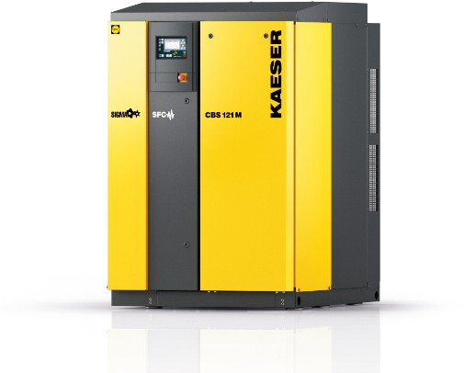
003_Image 1_KAESER-CBS.jpg
Caption: Rotary screw technology for blowers from Kaeser: the compact and powerful CBS series saves energy costs.

((Kaeser photo – free for publication))

