March 2021
Efficient and future-proof:
The latest generation all-in-one Aircenter from Kaeser Compressors

The latest generation of the compact and dependable Aircenter all-in-one compressed air systems from Kaeser are not only more efficient than ever before, but they also now include a future-proof compressed air refrigerant dryer.
Remaining proudly manufactured in Germany, the user-friendly Aircenter is a complete turnkey system which incorporates a Kaeser rotary screw compressor, an energy efficient refrigeration dryer and an air receiver all in one space-saving compact package. The space-saving design has long since made the Aircenter the ideal solution where space is at a premium, such as in auto body garages and workshops.

Efficient technology
For 5.5 to 9 kW requirements, the Aircenter incorporates the Kaeser SM series rotary screw compressor. For maximum efficiency, the SM 10 and SM 16 compressor models both have premium efficiency IE3 motors, and the SM 13 compressor model is now equipped as standard with a super-premium efficiency IE4 motor. These motors comply with and exceed prevailing New Zealand EECA regulations for 3 phase electric motors. IE4 motors are the technology of tomorrow, with current regulation introduced in January 2015 only requiring the use of IE3 Class motors. For the end user this translates into best possible compressor performance, reduced energy costs and significantly enhanced compressed air production efficiency - today.
For even greater intake volume and efficiency, the latest generation of SM series rotary screw compressors are also equipped with the SIGMA 06 screw compressor block, featuring even further refined Sigma Profile rotors. Together with the IE4 motor for example, Kaeser has been able to reduce the energy requirement of these compressors by up to 13 percent.

Future-proof compressed air refrigerant drying
From the end of 2019, all refrigerant dryers from Kaeser Compressors use the new R-513A refrigerant. This includes the refrigeration dryers that can be found in the Aircenter models.
R-513A refrigerant offers the most future-proof operating solution for refrigeration dryers. Utilising this climate-friendly refrigerant will assist New Zealand compressed air users in future-proofing their compressed air station, as New Zealand transitions to low-GWP refrigerants as part of the Ozone Layer Protection Amendment Regulation 2018.
All Kaeser refrigeration dryers are designed to provide maximum efficiency and energy cost savings. Thanks to the new refrigerant, they are also future-proof for their entire service life when it comes to applicable refrigerant legislation.
With sound levels as low as 62 dB(A) the Aircenter is also suitable at point of use. The SM series Aircenter compressed air systems are available with drive powers of 5.5 to 9 kW, and produce flow rates from 0.59 to 1.62 m³/min, designed for pressures up to 15 bar. For more information visit nz.kaeser.com or phone 0800 447 820.
-END- Free for publication, copy appreciated
Editors Notes
From 0.18 to 515 kW, Kaeser Compressors manufactures a wide range of compressors and associated auxiliary equipment that meet the varying requirements of a diverse range of industries and applications.

One of the world’s largest manufacturers of rotary screw compressors, Kaeser Compressors is represented globally in over 100 countries through a dedicated network of branches, subsidiary companies and authorised partners.

Kaeser Compressors NZ Limited provides comprehensive air compressor and blower sales and service throughout New Zealand from its offices in Auckland, alongside a dedicated and nationwide network of authorised partners.

For editorial and advertising enquiries contact: Beth Wood, Marketing Manager
Press office: +61 3 9791 5999 Fax: +61 3 9791 5733
E-mail: beth.wood@kaeser.com

KAESER COMPRESSORS NZ Limited
18B Tarndale Grove, Albany, Auckland 0632, New Zealand
Phone: +64 9 941 0499 Email: info.newzealand@kaeser.com
nz.kaeser.com
File: A-Aircenter-future-proof-nz
Approved for publication, copy acknowledgement appreciated
Images:

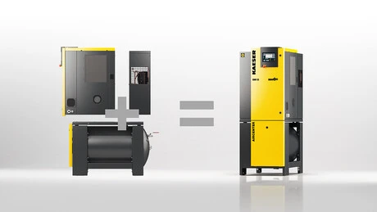
Caption: The Aircenter is the ideal solution where space is at a premium, such as in auto body garages and workshops.

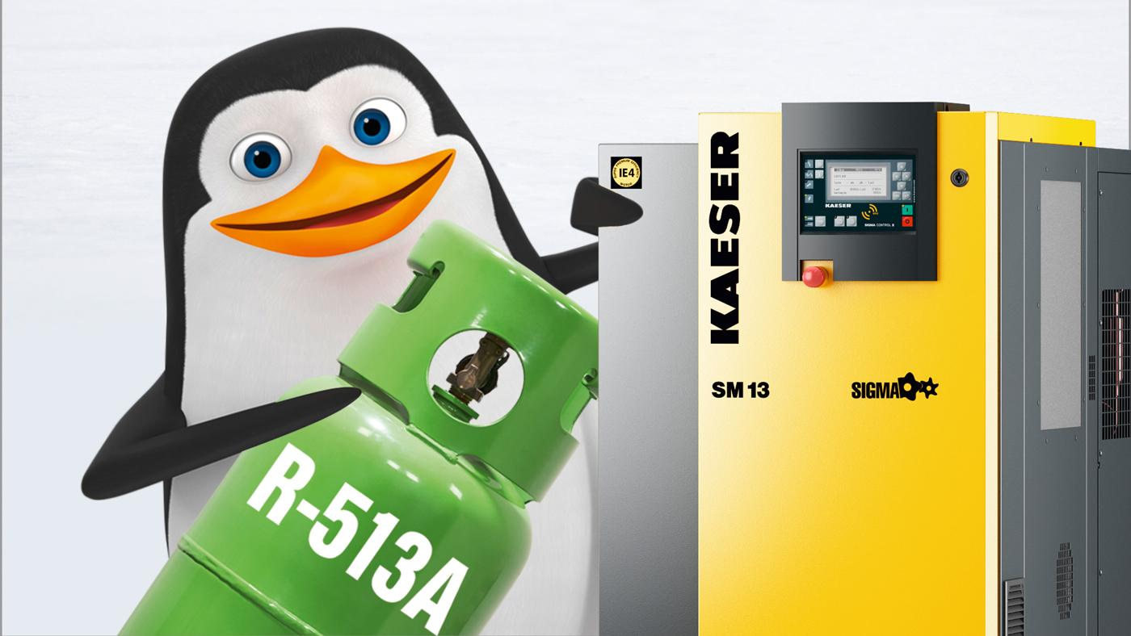
Caption: Future-proof: The refrigeration dryers in the latest generation Aircenter compressed air systems now use the new R-513A refrigerant.

Kaeser photo(s) – free for publication, credits appreciated.

