March 2020

Cream of the crop
Kaeser delivers a reliable supply of clean compressed air to DeLaval robotic milking systems

Reliability and efficiency are just two reasons why DeLaval in Australia and New Zealand are choosing Kaeser when it comes to delivering high quality and clean compressed air to its automated milking rotary’s. Most recently a Kaeser compressed air system was selected to accompany the DeLaval AMRTM system installed at Bannister Downs Dairy Farm in Western Australia.

Almost 10 years ago, DeLaval - a worldwide leader in milking equipment for dairy farmers - created the world’s first automatic milking rotary (AMRTM). Developed to meet the requirements of large dairy farmers wanting an automated milking system, the AMRTM enables up to 1,600 fully automatic milkings per day. To operate the AMRTM robots, the system relies on an efficient and clean supply of high quality compressed air, which in many cases is now supplied by a Kaeser compressed air system.

Delivering clean and high quality compressed air to the AMRTM
A consistent and clean flow of compressed air is critical to the reliable operation of the AMRTM.
Once the cows are collected in a waiting area a crowd gate may be used to slowly and calmly move the cows into the AMRTM platform. Preparation, milking and the exit stages of the milking process are then carried out by five robotic arms. Two arms manage preparation, two milking and one more manages the teat spraying at exit;

In the preparation stage, a cup is attached to the teat where a unique combination of air and water clean, stimulate and strip the teat ready for milking. The next robotic arm then attaches the separate milking cups, which commences the milking process. Once complete the first step in the exit process is delivered by the last of the five robotic arms. Finally before the cow exits the AMRTM, each teat is sprayed individually using a separate line and nozzle to eliminate any risk of milk contamination.

In delivering a fully operational AMRTM system to a dairy farmer DeLaval will also supply it complete with a compressed air system. Following on from a number of good experiences, DeLaval Australia and New Zealand now choose Kaeser as its preferred supplier. James Tomlin, the Technical Manager for Oceania at DeLaval explains: ‘Having had a number of good experiences using Kaeser compressed air systems in Europe with the AMRTM, we are now also opting for Kaeser with our installations in Australia and New Zealand. Kaeser compressed air systems have proven to be reliable in operation, backed up with good sales and service support.’

In action at Bannister Downs Dairy Farm
One AMRTM end user reaping the benefits of robotic milking and relying on a Kaeser compressed air system to operate many of its functions, are innovative dairy farmers Mat and Sue Daubney – co-owners of Bannister Downs Dairy Farm.

Bannister Downs Dairy Farm prides itself on delivering premium quality farm fresh products - from milk, cream and flavoured milks. Located in Northcliffe, which is in the lower South West region of Western Australia, they recently completed the build of their new Creamery. This greenfield site is where they now milk, process and dispatch all of their premium products daily to their customers.

In developing the Creamery every aspect was considered in the pursuit of excellence, and so it is no surprise then that this award winning facility is fitted out with technology that is leading global standards and is achieving the highest standard of product quality. This included the decision to invest in a DeLaval AMRTM complete with a Kaeser compressed air system for raw milk collection.

The AMRTM at Bannister Downs Dairy Farm operates 24 hours a day and is responsible for milking part of the 2,000 Holstein Fresian dairy herd. Once the on farm milking process is complete, the milk is transported just 10 metres through stainless steel pipework into the processing facility, where it is processed and packaged ready for daily dispatch.

To deliver a reliable supply of clean, dry and high quality compressed air to the AMRTM, two Kaeser SX 3 T series rotary screw compressors with integrated refrigeration dryers, complete with air treatment package and air receiver were installed.

The SX series from Kaeser are small but mighty compressors that not only deliver more compressed air for less energy but also combine ease of use and maintenance;

At the heart of the SX series rotary screw compressor lies the premium quality Sigma Profile screw compressor block. Operating at low speed, the Kaeser screw compressor block is equipped with flow-optimised rotors for superior efficiency. Furthermore, all SX series rotary screw compressors feature energy-saving, premium efficiency IE3 drive motors, which comply with and exceed prevailing New Zealand EECA regulations for 3 phase electric motors. For Bannister Downs Dairy Farm this means more compressed air for less energy consumption.

The compact SX T models also include an integrated refrigeration dryer which is installed in a separate enclosure. An automatic dryer shutdown feature further aids energy-efficient performance. In addition, a service-friendly design ensures that all maintenance and service components are easily accessible. This significantly reduces the downtime associated with such tasks and helps to increase compressed air availability and minimise operating costs.

Finally, to meet the air purity level required for food manufacture, Kaeser filters were also installed as part of the air treatment package. Thanks to lowest-possible differential pressure, these filters efficiently ensure compressed air of all purity classes as per the ISO 8573-1 standard. Using modern deep-pleated filter media, they remove particles and aerosols, while a highly effective carbon fibre mat traps oil vapours. Together with innovative flow dynamics, they deliver exceptional filtration efficiency with minimal pressure loss.

As fresh as it gets!
For Mat Daubney, having a reliable compressed air system is critical in the dairy being able to produce and deliver fresh products to its customers on a daily basis. He said; ‘the concept of robotic milking is still relatively new and the AMRTM at Bannister Downs is the first one DeLaval has built of its generation in Australia. We are relatively isolated – both being in Australia and our actual dairy location – which is even more reason why we need the AMRTM and the Kaeser compressed air system to be reliable.’
12 months on from installation and Mat is pleased to report that the Kaeser compressed air system has been running without incident; ‘and with a site that’s got quite a lot of new technology in it, that’s pretty good and something we’re really happy about’.

The SX series of rotary screw compressors from Kaeser are available with working pressures 7.5 to 15 bar, motor power 2.2 to 5.5 kW and free air deliveries 0.26 to 0.80 m³/min. For more information visit nz.kaeser.com or phone 0800 447 820.
-END- Free for publication, copy appreciated
Editors Notes
From 0.18 to 515 kW, Kaeser Compressors manufactures a wide range of compressors and associated auxiliary equipment that meet the varying requirements of a diverse range of industries and applications.

One of the world’s largest manufacturers of rotary screw compressors, Kaeser Compressors is represented globally in over 100 countries through a dedicated network of branches, subsidiary companies and authorised partners.

Kaeser Compressors NZ Limited provides comprehensive air compressor and blower sales and service throughout New Zealand from its offices in Auckland, alongside a dedicated and nationwide network of authorised partners.

For editorial and advertising enquiries contact: Beth Wood, Marketing Manager
Press office: +61 3 9791 5999 Fax: +61 3 9791 5733
E-mail: beth.wood@kaeser.com

KAESER COMPRESSORS NZ Limited
18B Tarndale Grove, Albany, Auckland 0632, New Zealand
Phone: +64 9 941 0499 Email: info.newzealand@kaeser.com
nz.kaeser.com
Kaeser photo(s) – free for publication, credits appreciated.

File: Q-DeLaval-Bannister-Downs-Case-Study-nz
Approved for publication, copy acknowledgement appreciated
Images: Contact our press office to request high res versions of the images found below
Compressor system
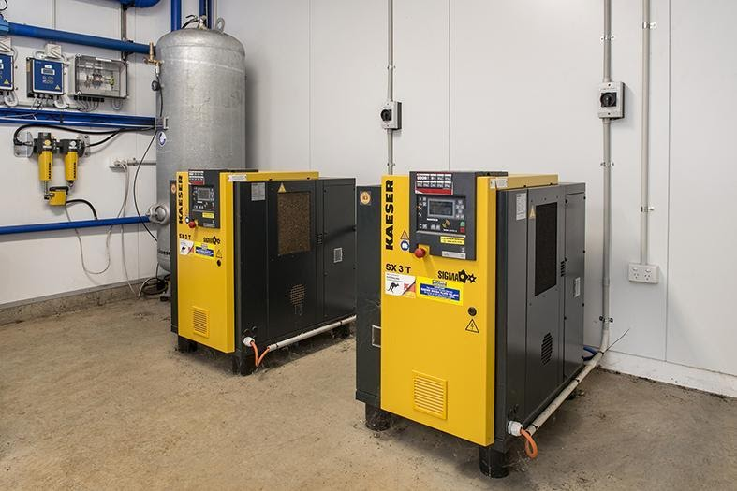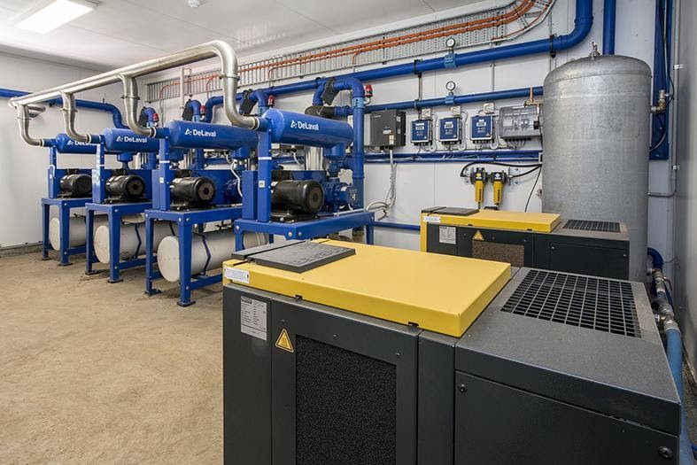
Caption: Two Kaeser SX 3 T series rotary screw compressors with integrated refrigeration dryers, complete with air treatment package and air receiver installed at Bannister Downs Dairy Farm.
AMRTM at Bannister Downs Dairy Farm
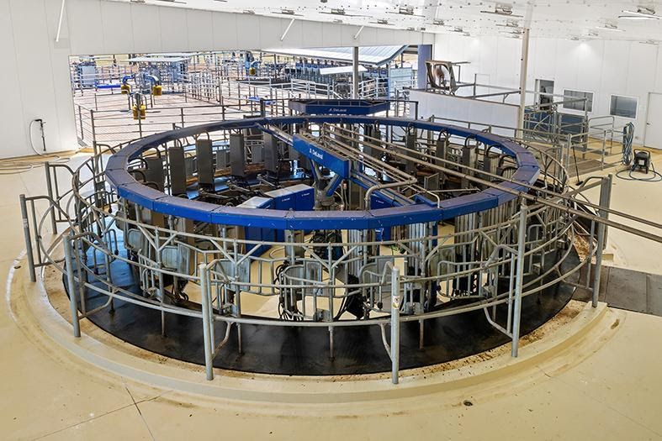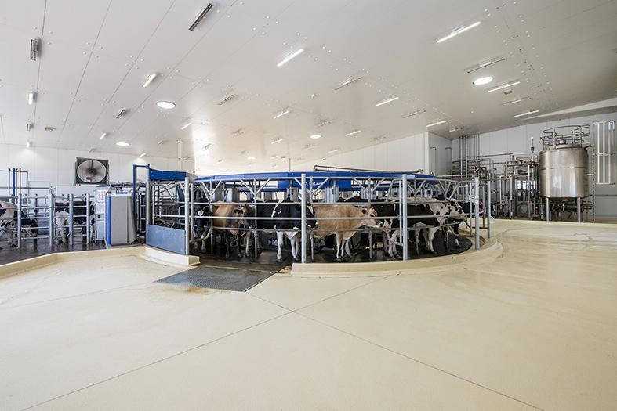
Caption: The DeLaval AMRTM system (automated milking rotary), here at Bannister Downs Dairy Farm.
AMRTM at Bannister Downs Dairy Farm in action
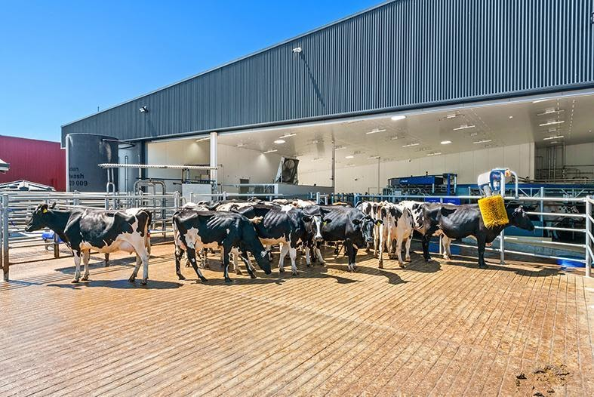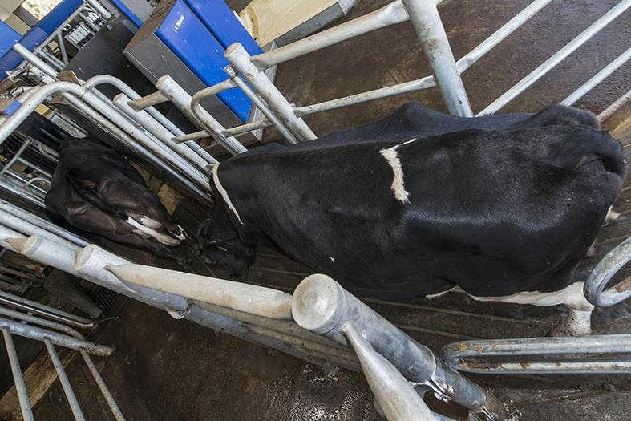
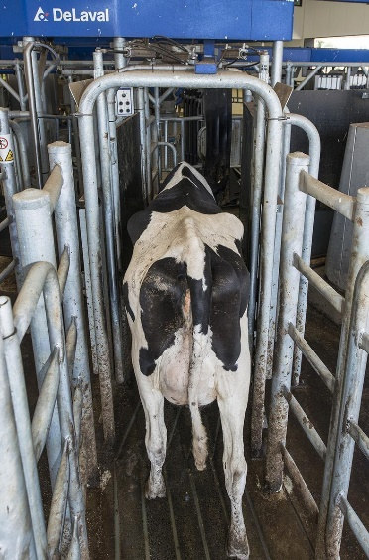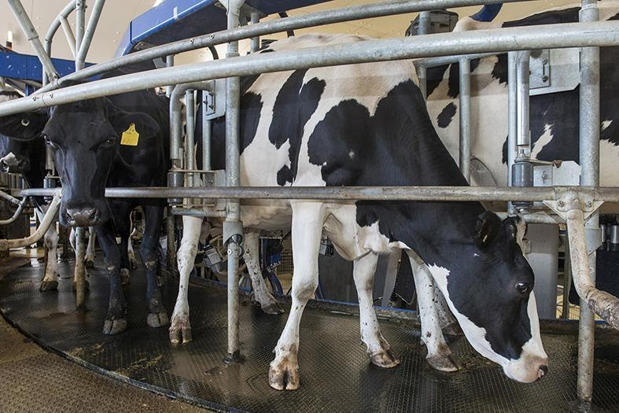
Caption: The cows are slowly and calmly moved into the AMRTM platform.
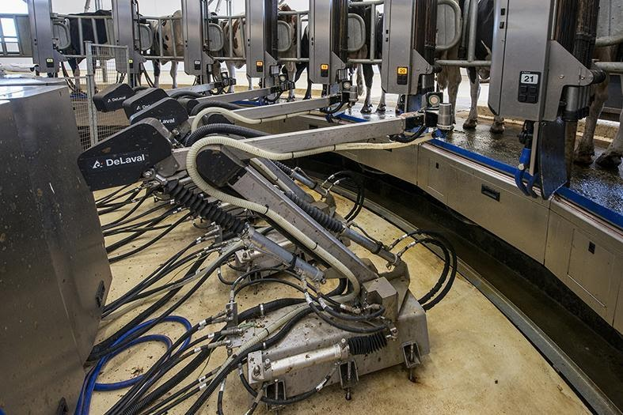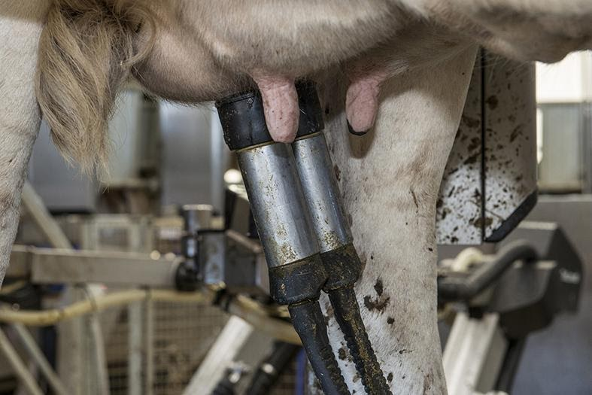

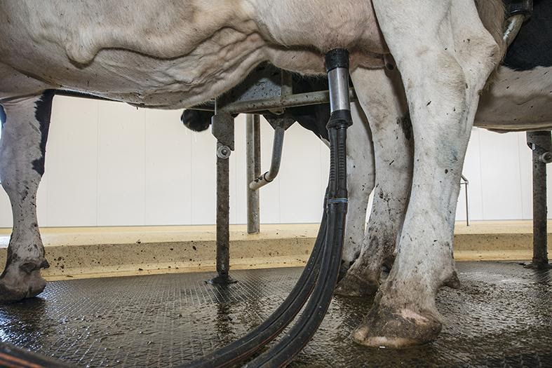
Caption: Preparation, milking and the exit stages of the milking process are carried out by five robotic arms.

Bannister Downs Dairy Farm
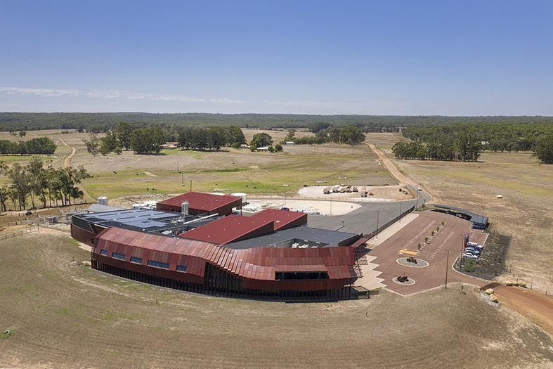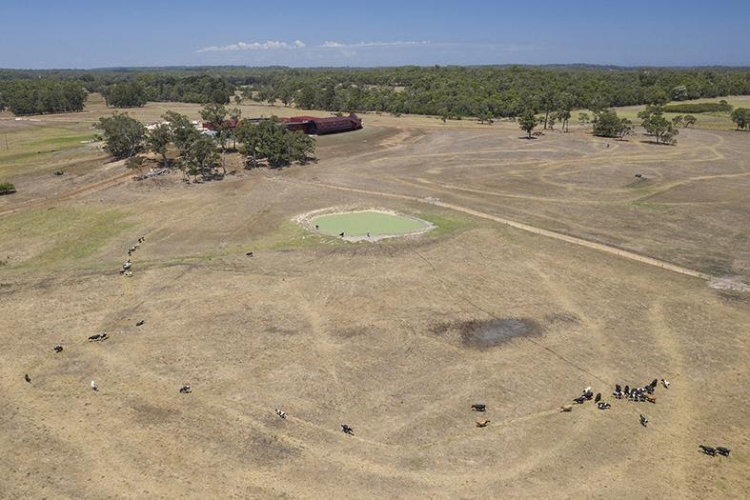
Caption: Bannister Downs Dairy Farm located in Northcliffe, Western Australia.

Bannister Downs Dairy Herd
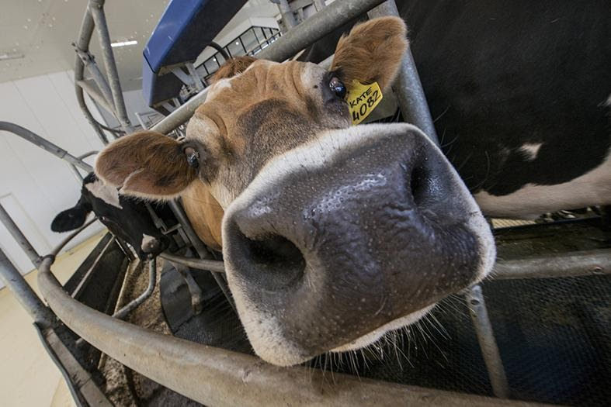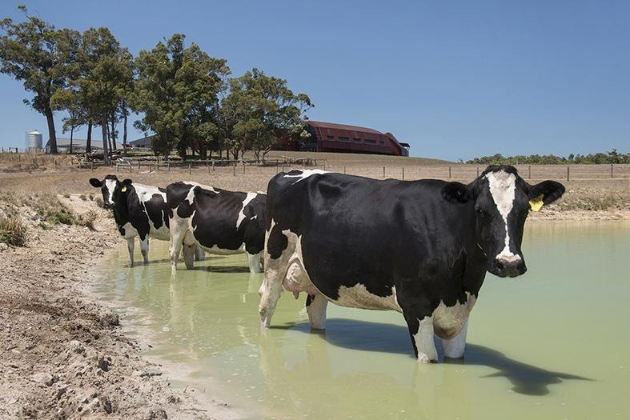
Caption: The AMRTM at Bannister Downs Dairy Farm operates 24 hours a day and is responsible for milking part of the 2,000 Holstein Fresian dairy herd.

The finished products
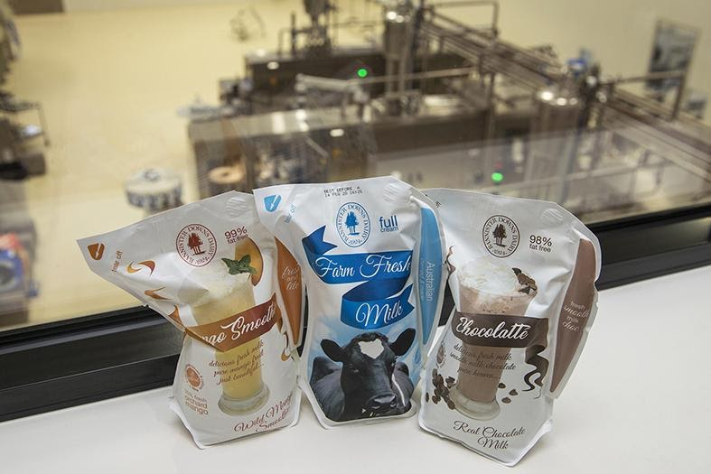
Caption: Bannister Downs Dairy Farm prides itself on delivering premium quality farm fresh products - from milk, cream and flavoured milks.

Kaeser photo(s) – free for publication.

