Exceptional Dry-Running Performance
Kaeser is proud to introduce its completely new ranges of dry-running, two-stage rotary screw compressors: The "DSG" and "FSG" series.
Ensuring exceptional performance, these two specialised ranges of rotary screw compressors have been designed for applications where dry compression is specifically required. Frequency controlled versions are also available to meet fluctuating compressed air demand and all models feature water- or air-cooling as required. The two ranges cover free air deliveries from 13.5 up to 50 m³/min (fixed speed), or 6.8 to 51.8 m³/min (SFC frequency control).

At the heart of these versatile units lies a quality, two-stage compressor airend. The rotors are equipped with “Ultra Coat”, which is resistant to temperatures up to 300 °C. Because this cost-reducing coating is also highly abrasion-proof, its sealing and protection performance remains virtually unchanged even after years of operation. As a result, compressed air delivery also remains consistent. In other words, dry-running rotary screw compressors from Kaeser consume no more energy after years of use than when first commissioned in order to deliver their rated free air delivery. “Ultra Coat” therefore helps to keep total system costs to a minimum.

Moreover, Kaeser's unique system design reduces costs further, as air can be used to provide dependable air cooling in ambient temperatures as high as 45 °C for units with drive powers of up to 315 kW (355 kW with frequency control). Dependability and efficiency are also enhanced by the PC-based "Sigma Control 2": Using up to 20 measuring points, this advanced system is able to permanently gather both temperature and pressure data thereby guaranteeing optimum reliability and monitoring.

All models are equipped with premium efficiency IE3 rated motors and feature a range of pre-programmed control modes. This consequently allows precision optimisation of compressor energy consumption in base-, mid- and peak load operation.
These advantages, coupled with numerous other technical refinements, ensure that every unit lives up to the Kaeser quality promise. For example, the use of chromium steel rotors in the second compression stage helps guarantee compressed air quality and significantly enhances service life. In addition, as air intake is regulated via a hydraulically operated inlet valve, there's no need for regular replacement of pneumatic diaphragms. This consequently reduces both service costs and downtime. Furthermore, the use of fibre-free pulse dampers keeps pressure loss to an absolute minimum, maintains consistent air quality and prevents contamination of the compressed air.

Last, but not least, these new models continue the Kaeser tradition of super-quiet performance. Using the very latest in computer-aided measurement technology, the Kaeser development engineers were able to precisely analyse all sound sources and therefore ensure that these versatile systems operate with minimal sound levels.

File: A-DSG-FSG-aus
Approved for publication, copy acknowledgement appreciated

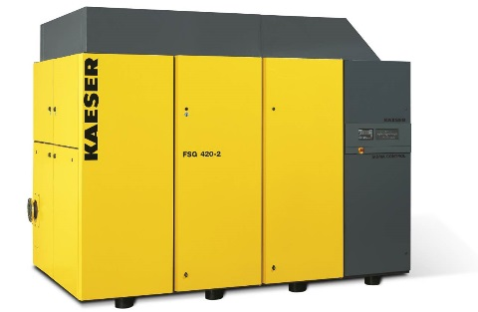

Caption:

Powerful, durable, efficient: The new DSG and FSG series of dry-running rotary screw compressors from Kaeser. Available with cost-effective air-cooling for drive powers up to 355 kW.

Kaeser photo – Free for publication

