January 2022

Knowledge is power!
Kaeser launches its Webinar Programme for 2022

Kaeser Compressors New Zealand has launched its Webinar Programme for 2022. This programme includes the return of the popular ‘Compressed Air Webinar’, as well as continued sponsorship of the MESNZ’s Lunch and Learn Webinar series.
Kaeser Compressors is committed to supporting the compressed air industry with training and education, firmly believing that knowledge really is power when it comes to operating a reliable, dependable and energy efficient compressed air system. As Peter Eckberg, Managing Director of Kaeser Compressors NZ said: ‘Providing compressed air reliably and efficiently at the required quality is a complex process and requires careful consideration of the complete compressed air supply system. The widest possible knowledge base is therefore required in order to properly assess the various interactions within the system and its integration into the operational environment.’
For that reason many years ago Kaeser developed the Compressed Air Seminar. This traditional face-to-face event required delegates to dedicate a full day away from the office. However the remastered and online version which Kaeser launched last year - ‘The Compressed Air Webinar’ - is conveniently run online and at lunchtime.

‘The response to our inaugural webinar programme last year was very encouraging, and it was clear that whether or not COVID-19 restrictions allowed us to return to face-to-face events in 2022, many of our end users have grown to prefer the webinar medium, which presents to them a much more convenient way to tap into such resources.’

The Compressed Air Webinar
The Compressed Air Webinar has been specifically developed to provide a solid compressed air knowledge base for all those involved in the planning, installation, operation and maintenance of compressed air supply systems.

The complete Compressed Air Webinar is broken down into three 90 minute modules, that are held online and over three consecutive weeks. From the fundamental principles of compressed air to compressed air treatment, regulations and control systems - the Compressed Air Webinar from Kaeser, provides participants with the knowledge that can ultimately assist them in optimising the reliability and energy efficiency of a compressed air system.

The Compressed Air Webinar is scheduled to run in May and September 2022. Registrations are now open - just visit nz.kaeser.com

MESNZ Lunch and Learn Webinar Series
Kaeser is delighted to be continuing its sponsorship of the Maintenance Engineering Society of New Zealand (MESNZ) Lunch and Learn Webinar Series in 2022. Bringing together members and interested parties for one hour webinars held at a lunchtime, the MESNZ Lunch and Learn Webinar Series features industry speakers who provide insights on a range of topics. Kaeser will also be hosting a couple of these webinars within 2022 focusing specifically on key compressed air topics.

For more information on Kaeser Compressors 2022 Webinar Programme, visit nz.kaeser.com or phone 0800 447 820.
-END- Free for publication, copy appreciated
Editors Notes
From 0.18 to 515 kW, Kaeser Compressors manufactures a wide range of compressors and associated auxiliary equipment that meet the varying requirements of a diverse range of industries and applications.
One of the world’s largest manufacturers of compressors, blowers and compressed air systems, Kaeser Compressors is represented throughout the world by a comprehensive network of branches, subsidiaries and authorised distribution partners in over 140 countries.

Kaeser Compressors NZ Limited provides comprehensive air compressor and blower sales and service throughout New Zealand from its offices in Auckland, alongside a dedicated and nationwide network of authorised partners.

For editorial and advertising enquiries contact: Beth Wood, Marketing Manager
Press office: +61 3 9791 5999 Fax: +61 3 9791 5733
E-mail: beth.wood@kaeser.com

KAESER COMPRESSORS NZ Limited
18B Tarndale Grove, Albany, Auckland 0632, New Zealand
Phone: +64 9 941 0499 Email: info.newzealand@kaeser.com
nz.kaeser.com
File: P-Webinars-2022-nz
Approved for publication, copy acknowledgement appreciated
Images:
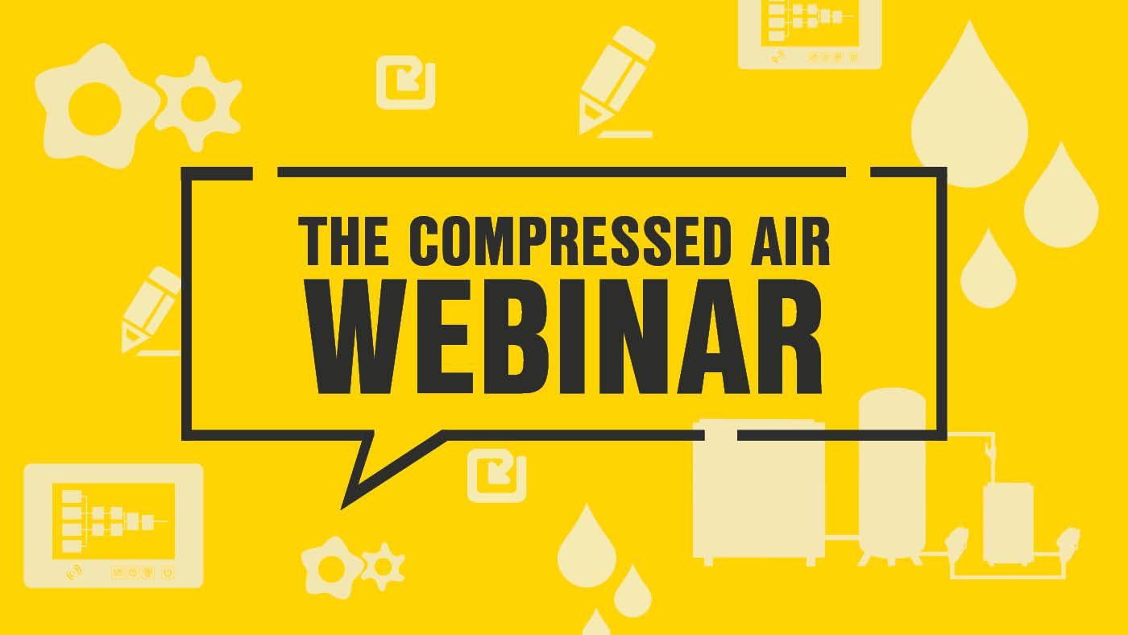
Caption: Kaeser Compressors is once again running its popular Compressed AIr Webinar in 2022
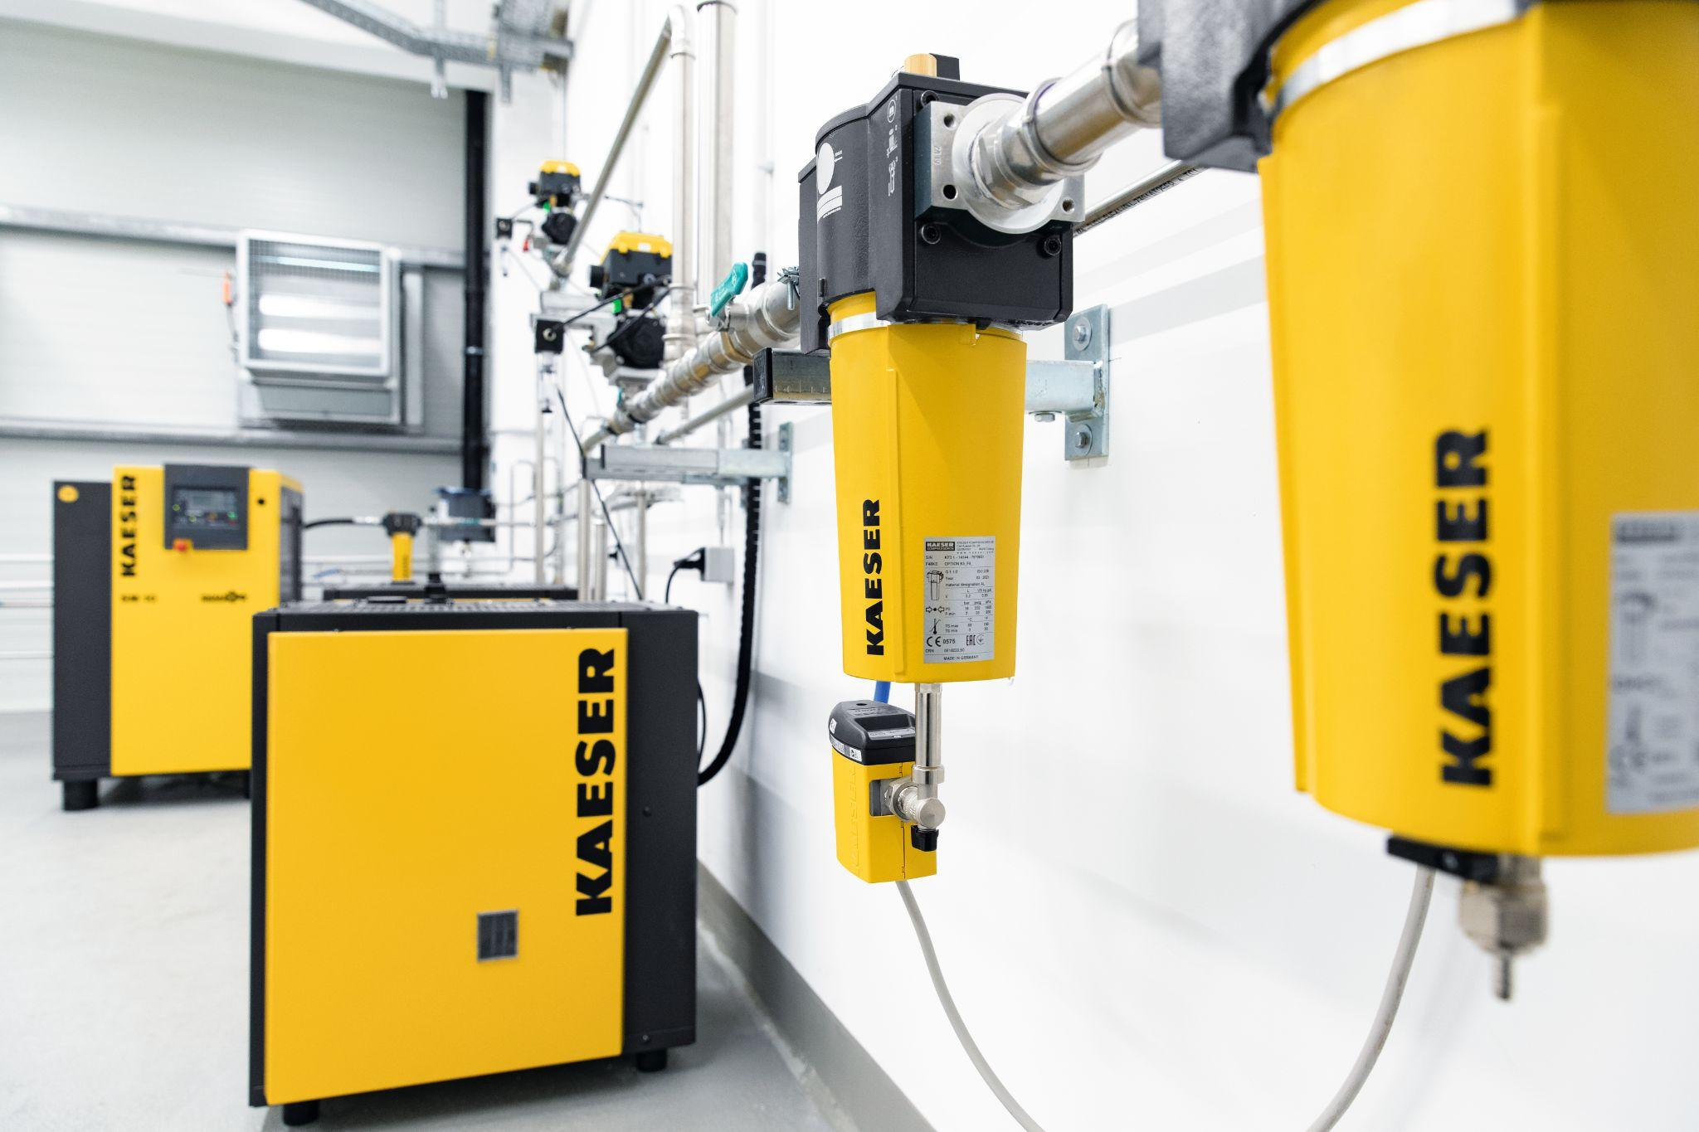
Caption: Operating a reliable, efficient and dependable compressed air system requires the widest possible knowledge base (pictured a Kaeser compressed air supply system)

((Kaeser photo – free for publication))

