May 2019

Kaeser at HIANZ Conference 2019: rugged dependability for the hire industry

Kaeser Compressors will present its rugged and dependable range of Mobilair portable compressor solutions at the Hire Industry Association of New Zealand (HIANZ) Conference 2019, being held at Claudelands Event Centre in Hamilton from 2 to 4 July.

Wherever compressed air is needed - even in the toughest conditions - Kaeser Compressors has a portable solution to offer from its rugged and dependable range of Mobilair compressors. Manufactured at a state-of-the-art production facility in Germany, the renowned Mobiliar range of portable compressors are powerful machines that feature advanced, fuel-saving motors and heavy-duty chassis.

At this year’s HIANZ Conference delegates are invited to join Kaeser on stand number 29 to learn more about the Mobilair range. This includes the M500-2 dry running diesel driven portable screw compressor, which is the ideal solution for leasing companies, combining the advantages of a dry-running rotary screw compressor with those of a portable machine. In addition, the Mobilair 500-2 can be easily integrated into compressor stations controlled by a master control system.

The perfect choice where large volumes of compressed air are required, the M 500-2 from Kaeser can be used in industrial applications, especially when it is needed to bridge maintenance outages or when a plant is being upgraded. Other potential applications include tunnel construction and pipeline flushing in refineries.

At the heart of the Mobilair 500-2 is a proven two-stage dry running rotary screw compressor. Thanks to an innovative special coating that withstands temperatures up to 300ºC, the machines sandblasted, phosphated rotors show no signs of wear, even after many years of operation. This translates to consistent high energy efficiency and no increase in fuel consumption over the operating life of the machine. A large capacity fuel tank enables back-to-back operation over two shifts without the need to refuel. Continuous operation is also possible via an optional external fuel tank. The reliable on-board Caterpillar C18 diesel engine is rated at 447.5 kW.

The Mobilair 500-2 comes with an integrated Sigma Control mobile controller which automatically adjusts the motor speed to the exact pressure set-point between 4 and 10.3 bar. Compressed air discharge temperature can also be selected via the controller. The M500-2 comes as standard with a spark arrestor and motor shutoff valve for installation in refineries and is mounted on a supporting chassis with parking brake so that it can be quickly and safely positioned anywhere. It also features crane and lashing eyes, as well as forklift pockets. This giant unit, which weighs in at just less than twelve tonnes, can therefore be precisely placed exactly where needed; the parking brake on the chassis also ensures that it stays put.

In the unlikely event of a fault, the integrated Mobilair fleet management system can automatically notify Kaeser Air Service. The Mobilair fleet management system also supplies the leasing company with a steady stream of data that can be used for invoicing, documents the machine's location and provides notification when maintenance is required during long-term use. Everything is accessible online.

To learn more about the M500-2 as well as the complete range of Mobilair portable compressors, join Kaeser on stand 29 at the HIANZ Conference 2019, Claudelands Event Centre in Hamilton, 2 - 4 July. For more information visit www.kaeser.co.nz or phone 0800 447 820.
-END-
Editors Notes
From 2.2 to 500 kW, Kaeser Compressors manufactures a wide range of compressors and associated auxiliary equipment that meet the varying requirements of a diverse range of industries and applications.

One of the world’s largest manufacturers of rotary screw compressors, Kaeser Compressors is represented globally in over 100 countries through a dedicated network of branches, subsidiary companies and authorised partners.

Kaeser Compressors NZ Limited provides comprehensive air compressor and blower sales and service throughout New Zealand from its offices in Auckland, alongside a dedicated and nationwide network of authorised partners.

For editorial and advertising enquiries contact: Beth Wood, Marketing Manager
Press office: +61 3 9791 5999 Fax: +61 3 9791 5733
E-mail: beth.wood@kaeser.com

KAESER COMPRESSORS NZ Limited – 18B Tarndale Grove, Albany, Auckland 0632, New Zealand
Phone: +64 9 941 0499 – www.kaeser.co.nz – E-mail: info.newzealand@kaeser.com

File: O-HIANZ-NZ-2019-preview-nz
Approved for publication, copy acknowledgement appreciated
Image:
((Captions)) :
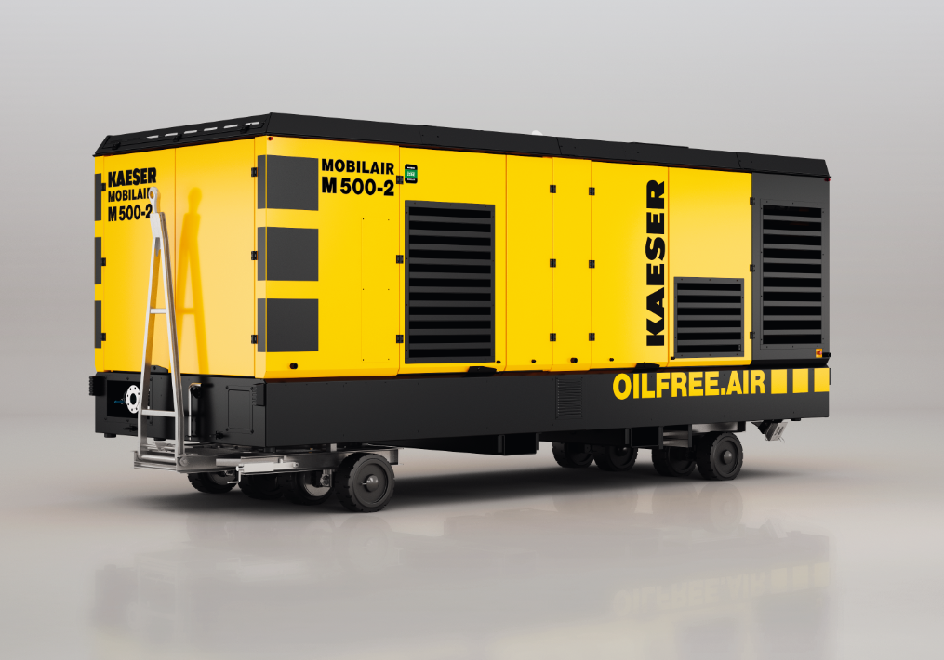
Caption: The ideal solution for leasing companies, the Mobilair 500-2 provides a powerful, versatile and energy efficient supply of portable compressed air.
((Kaeser photo – free for publication))

