sshhmute gets down to brass tacks with Kaeser
Bremner Music, the creators of the sshhmute practice mute, recently invested in a Kaeser Classic 460 / 50 W workshop compressor, to meet its requirements for a high quality and reliable supply of compressed air in the assembly of the practice mutes at its facility in New Zealand.
It's a common problem often faced by brass instrument players; how to practice at odd times and in odd places with minimum noise and without changing the pitch or projection of the instrument. Trevor Bremner, an Australian and New Zealand Cornet Champion and teacher had faced this problem himself many times. It was his dissatisfaction with solutions currently on the market place that led him to invent the sshhmute Practice Mute.
Developed over several years in his New Plymouth workshop in New Zealand, the sshhmute Practice Mute is now in full commercial production and has been successfully launched to answer a market need for an effective mute for brass instruments in a price range to suit budding musicians and professionals alike.
In the initial stages of production, the two parts of the sshhmute practice mute were bonded together manually with solvents. However now sold in over 33 countries, as demand has grown for the product, Bremner Music realised they needed to invest in a plastic welding machine to accelerate the production process.
A reliable supply of compressed air was required to power the new welding machine. Having heard that Kaeser compressors were known for their German quality and high reliability, Trevor Bremner contacted his local authorised Kaeser partner - Pace Power & Air for a solution.
Pace Power & Air worked closely with Bremner Music to spec up the correct compressor for the application. They recommended and subsequently installed a Kaeser Classic 460 / 50 W workshop compressor.
The Kaeser Classic series workshop compressors are designed and built to the strictest quality standards, yet are priced to meet the needs of small compressed air users without compromising efficiency, reliability and durability. The compressor block forms the heart of these units and is manufactured at Kaeser's main production facility in Coburg, Germany. All Kaeser Classic compressors require minimal maintenance and are designed to provide years of efficient and reliable service.
Installed and operating now for almost 12 months, the Kaeser Classic compressor reliably powers the plastic welder that is used in the assembly of 5 out of 8 sshhmute Practice Mute models. Trevor Bremner said: 'The Kaeser compressor has proven to be a convenient 'plug and play' solution that is certainly living up to our expectations.'
Manufactured in Germany to the highest quality standards, the Kaeser Classic series workshop compressors are available with displacement from 210 to 460 l/min, pressure 10 bar.

File: Q-sshhmute-nz
Approved for publication, copy acknowledgement appreciated
Images: (contact the press office for high res copies of the following images)

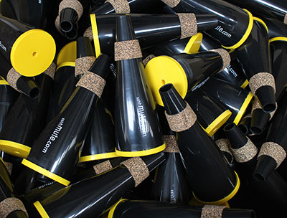
Caption: The sshhmute Practice Mute is now sold in over 33 countries

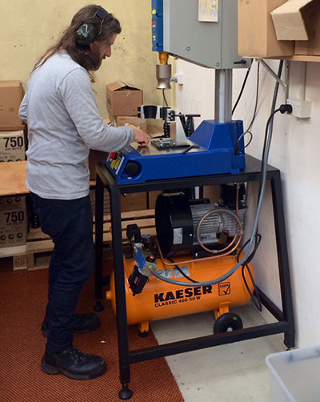
Caption: A Kaeser Classic workshop compressor powers the plastic welder used in the assembly of the sshhmute Practice Mute

Caption: Trevor and Betty Bremner, the designers of the sshhmute Practice Mute

