June 2018

Technology of the future:
Low pressure 4.0

Intelligent and straightforward blower control: the Sigma Air Manager 4.0 is the solution for blower station automation. This sophisticated controller delivers maximum energy efficiency and cost savings whilst making the station ready for Industrie 4.0 applications.

The Sigma Air Manager 4.0 from Kaeser Compressors, is the core component of a blower station and the key technology needed in order to take advantage of the Industrie 4.0 services of the future. It acts as the central mastermind and controls the individual machines with maximum efficiency whilst perfectly adjusting the flow capacity to match flow rate demand. All it needs from the process control system is the desired differential pressure value – the SAM 4.0 then ensures optimal control of all blowers. Partial-load bridging and individual solutions are therefore things of the past, along with complicated setups. Now, all applications are supplied by one central blower station with a master controller that analyses operating data in seconds and simulates various scenarios in order to select the most efficient solution. The result? Previously unimaginable energy efficiency.

All components within the station are optimally matched and controlled to meet the customer’s specific needs. Real-time process monitoring provides valuable operating data, which is forwarded for detailed evaluation. The analysed results help to predict potential faults as early as possible and prevent them by taking timely action.

The SAM 4.0 offers communication in 30 languages whilst the easy-to-operate 12-inch colour touchscreen display shows at a glance whether the station is operating in the “green zone” for optimal energy performance. It’s incredibly easy to display and analyse a wealth of data, such as operating status, pressure curve, flow rate and power, as well as maintenance and any fault messages. And, thanks to a network connection, this can be done not only at the machine itself, but also conveniently from a PC at the office or elsewhere. This powerful capability therefore provides peace of mind and lays the foundation for predictive maintenance; it also enables sophisticated energy management per ISO 50001.

The master controller also makes it possible to take advantage of new options for predictive maintenance of blowers. Previously, maintenance could only be performed on the basis of a regular scheduled service date and repairs would be made only after a fault message had occurred. The SAM 4.0 now makes it possible to initiate maintenance before a fault occurs, thereby avoiding costly downtime and consequential damage.

The sensors and Sigma Control 2 controller integrated into the machine collect process data, which is immediately forwarded to the Sigma Air Manager 4.0. Specialised software is then used to transfer the information to the Kaeser Data Center for real-time analysis. The Kaeser Data Center performs central monitoring and processing of operating messages. Required predictive maintenance measures are then initiated as needed based on this information.
Ultimately this enables maintenance and necessary repairs to be performed at the precise moment they are actually needed. This saves time, minimises costs and ensures reliable blower availability, which in turn benefits all associated downstream processes.

For more information visit www.kaeser.co.nz or phone 0800 447 820.
-END-
From 2.2 to 500 kW, Kaeser Compressors manufactures a wide range of compressors and associated auxiliary equipment that meet the varying requirements of a diverse range of industries and applications.

One of the world’s largest manufacturers of rotary screw compressors, Kaeser Compressors is represented globally in over 100 countries through a dedicated network of branches, subsidiary companies and authorised partners.

Kaeser Compressors NZ Limited provides comprehensive air compressor and blower sales and service throughout New Zealand from its offices in Auckland, alongside a dedicated and nationwide network of authorised partners.

For editorial and advertising enquiries contact: Beth Wood, Marketing Manager
Press office: +61 3 9791 5999 Fax: +61 3 9791 5733
E-mail: beth.wood@kaeser.com

KAESER COMPRESSORS NZ Limited – 18B Tarndale Grove, Albany, Auckland 0632, New Zealand
Phone: +64 9 941 0499 – www.kaeser.co.nz – E-mail: info.newzealand@kaeser.com

File: H-SAM-4-0-low-pressure-4-0-nz
Approved for publication, copy acknowledgement appreciated
Image:
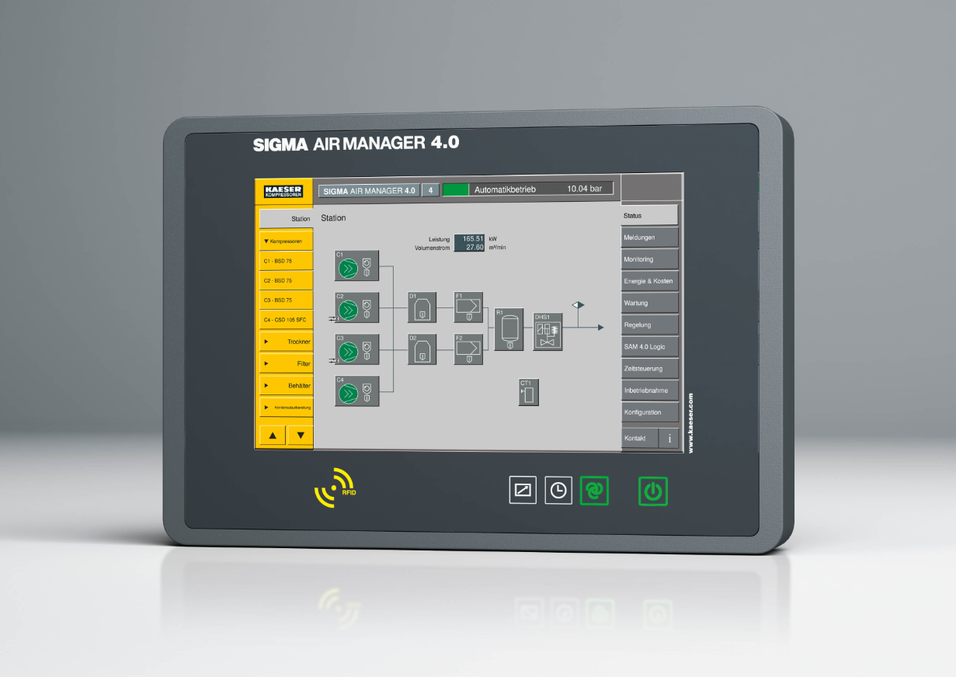

Caption: The Sigma Air Manager 4.0 not only monitors and controls all components of a blower station with maximum efficiency, but also provides full Industrie 4.0 capability.
013_Image 1_KAESER SAM 4.jpg

((Kaeser photo – free for publication))

