January 2026
Bottling Success:
How Fino Valley Wines achieved uninterrupted compressed air reliability with Kaeser
A Kaeser SXC 4 all-in-one compressed air system is assisting Fino Valley Wines in Auckland, in successfully scaling production and achieving uninterrupted operational reliability. Complete with filtration, the new compressed air system is providing the essential high air quality needed for the wineries new bottling line, enabling a dramatic increase in output while eliminating reliance on costly bottled nitrogen supply.
Fino Valley Wines is one of the oldest wineries in Auckland. Established in 1966, this family-owned operation has over a 100-year history of winemaking tradition. The winery sources its grapes from the family’s vineyards spanning Auckland, Hawke’s Bay, and Marlborough, and is focused primarily on Sauvignon Blanc, Pinot Noir, and Bordeaux blends.
All wines are finished and bottled at the Henderson Valley winery, where compressed air is crucial to the process. It drives the pneumatic components responsible for precisely lifting and positioning bottles, controlling the filling process, and activating the sealing jaws. And today, it is also critical to maintaining a quality product as it serves as the feed source used to generate the nitrogen gas necessary to protect the wine from oxygen exposure at the most critical stages.
Uninterrupted compressed air reliability
With an annual capacity exceeding 250,000 litres, maintaining uninterrupted production reliability is an absolute necessity to meet Fino Valley Wines’ growing worldwide exports. To that end, the company recently invested in a new bottling machine. Unfortunately, the existing compressed air system was unable to consistently meet the demands of the new bottling line. As Ivan Tvrdeich, Winemaker at Fino Valley Wines, explained: "Our older compressed air unit simply couldn’t handle the new bottling line. We needed something reliable, with the performance to run without interruption."
Kaeser went beyond simply addressing the new bottling line's compressed air demand, identifying a significant opportunity to further optimise operations. They proposed utilising the compressed air system to generate the nitrogen required for the bottling line on-site, replacing the winery’s costly reliance on purchasing bottled nitrogen. This shift to on-site generation guarantees nitrogen is available precisely when needed and presented a more cost effective solution.
Fino Valley Wines therefore required a new compressed air system solution that could meet the increased demands of the new bottling line, reliably operating from early morning through late evening schedules, while strictly adhering to the high air quality standards required for winemaking. The system also needed to operate continuously to power the nitrogen generator overnight, ensuring a sufficient supply was available for the following day's bottling operations.
Optimising compressed air and on-site nitrogen supply
To achieve this dual goal, Kaeser recommended the SXC 4 all-in-one compressed air supply system. This complete turnkey solution integrates a compressor, air receiver, and refrigeration dryer, all within one durable, double-walled enclosure. Compact and quiet in operation, every SXC compact package features a rotary screw compressor airend with high-efficiency Sigma Profile rotors to ensure more compressed air for less energy. Furthermore, the advanced Sigma Control 2 compressor controller guarantees reliable and efficient operation with maximum availability.
A demo SXC 4 compressed air package, equipped with the necessary filtration to meet the required high air quality standards, was subsequently installed for trial. The team at Fino Valley Wines quickly realised it was the correct solution to meet their needs, leading them to invest in a brand-new machine of the same model.
Maximising production and reliability
Since the installation of the Kaeser SXC 4 compressed air package, Fino Valley Wines has seen a dramatic increase in production, enabling the winery to meet growing global demand with confidence.
The new compressed air system is reliably operating around the clock, serving the bottling operation throughout the day while supplying the necessary feed air for the on-site nitrogen generator overnight. Generating nitrogen on-site has not only reduced costs for the winery but also guarantees a reliable, on-demand supply, which is critical for maintaining high levels of bottling efficiency. This continuous, high-quality compressed air supply is essential for maximising the efficiency of the new bottling line and safeguarding the purity of the premium wines.
As Ivan Tvrdeich confirms, this turnkey solution has delivered significant operational advantages: "The unit is very easy to use, much quieter than our old compressor, and very reliable. It’s a hands-off solution and the Kaeser team takes care of servicing, so we don’t have to worry. The compressor is way more reliable than our old system, and we never run out of air. It is a really good unit and is exceeding our expectations.”

For more information on our products, visit nz.kaeser.com or call 0800 447 820.
-END-
Editors Notes
Kaeser Compressors is one of the world’s leading compressor manufacturers and compressed air system providers, represented internationally by a comprehensive network of subsidiaries and authorised distribution partners in over 140 countries.

Kaeser’s comprehensive product range comprises; reciprocating and rotary screw compressors ranging from 0.18 to 515 kW, portable rotary screw compressors, high-pressure and dry-running compressors, compressor control systems, vacuum pumps, rotary blowers, rotary screw blowers, turbo blowers, air filters, refrigeration & desiccant dryers, as well as compressed air system accessories and services.
Established in 2015, Kaeser Compressors NZ Limited, provides comprehensive sales and service throughout New Zealand, from its facility in Auckland, alongside an extensive network of authorised partners.
For editorial and advertising enquiries contact:
Press office: +64 9 941 0499 E-mail: marketing.nz@kaeser.com
KAESER COMPRESSORS NZ Limited
18B Tarndale Grove, Albany, Auckland 0632, New Zealand
Phone: +64 9 941 0499 Email: info.newzealand@kaeser.com Web: nz.kaeser.com

((Kaeser photo – free for publication))

Images:

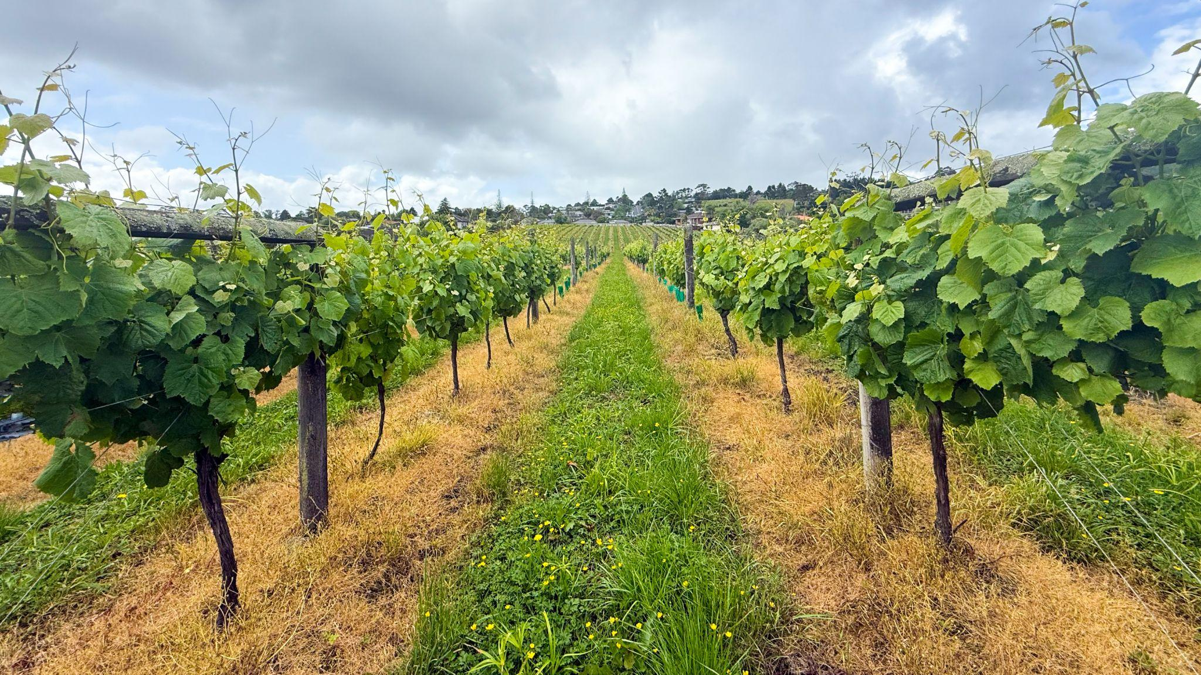

Caption: Pictured the Bottom block at Fino Valley Wines’ Henderson Valley Vineyard.

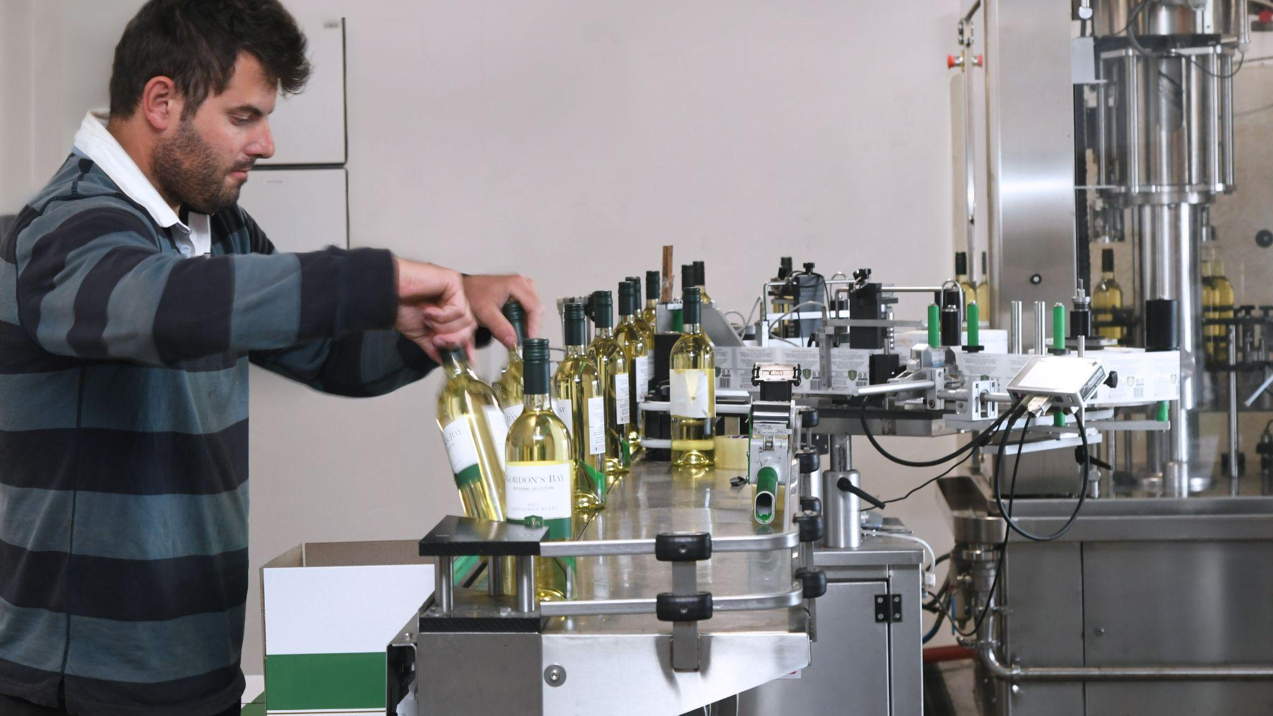

Caption: The new bottling line complete with KAESER compressed air system has allowed Fino Valley Wines to dramatically increase production.

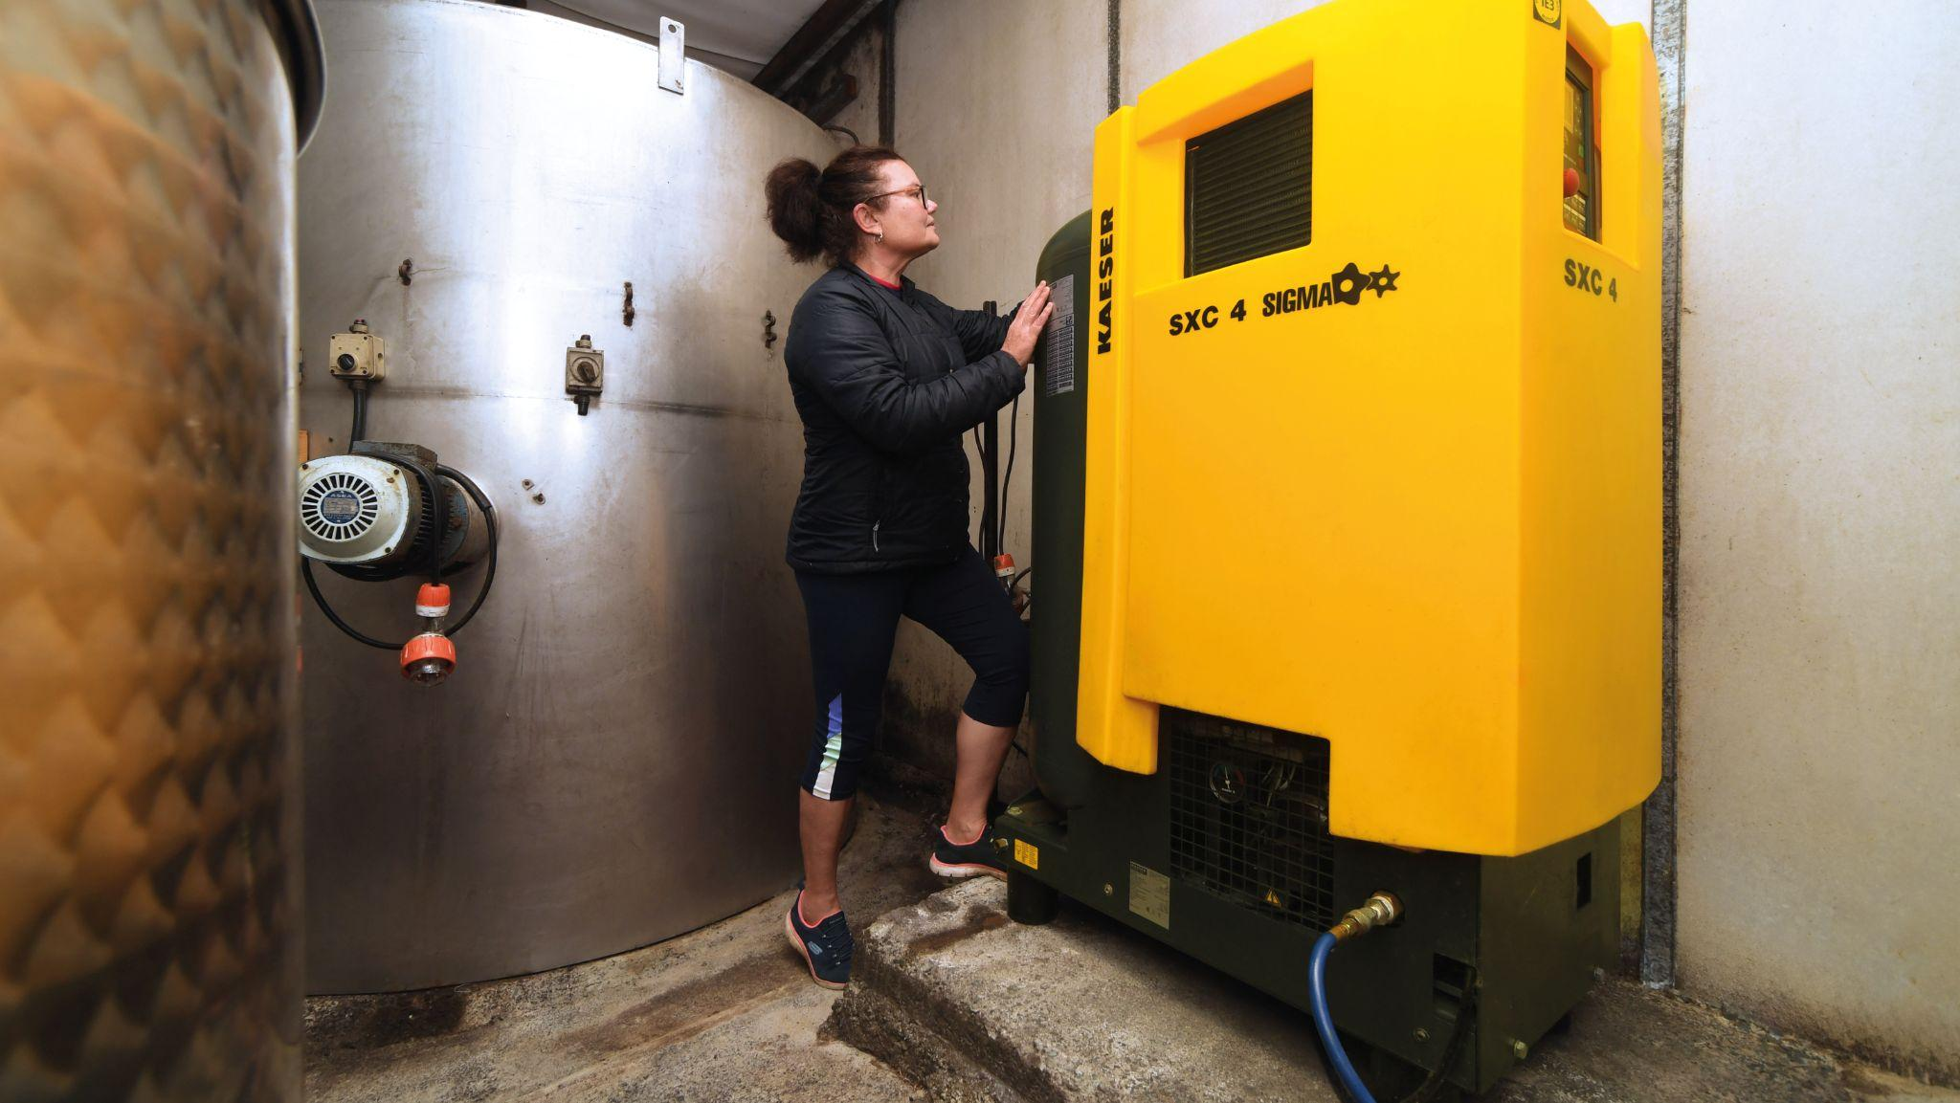

Caption: The Kaeser SXC 4 has exceeded Fino Valley Wines expectations.

